**Casio Male**

|  |  |
| --- | --- |
| **DETAILS**  **Brand** | **Casio** |
| **Place of origin** | **Japan** |
| **Product Line** | **G-SHOCK** |
| **Machine type** | **Quartz** |
| **Gender** | **Male** |
| **Diamete** | **55 x 51,2 x 16,9mm** |
| **Case Material** | **Plastic high-class** |
| **String material** | **Rubber band** |
| **Glass material** | **Hard glass** |
| **Water Resistance** | **200M** |
| **Warranty international** | **1 year** |
| **Warranty at WATCH Time** | **3 years** |

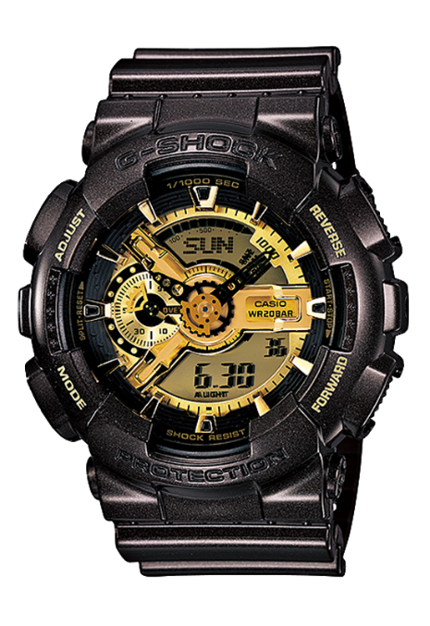

Casio G-Shock GA-110BR-5ADR

Order online: 4.590.000 VND

List price : 5.100.000 VND

|  |  |
| --- | --- |
| **DETAILS**  **Brand** | **Casio** |
| **Place of origin** | **Japan** |
| **Product Line** | **G-SHOCK** |
| **Machine type** | **Quartz** |
| **Gender** | **Male** |
| **Diamete** | **55 x 51,2 x16,9mm** |
| **Case Material** | **Plastic** |
| **String material** | **Cao su** |
| **Glass material** | **Hard glass** |
| **Water Resistance** | **200M** |
| **Warranty international** | **1 year** |
| **Warranty at WATCH Time** | **3 years** |

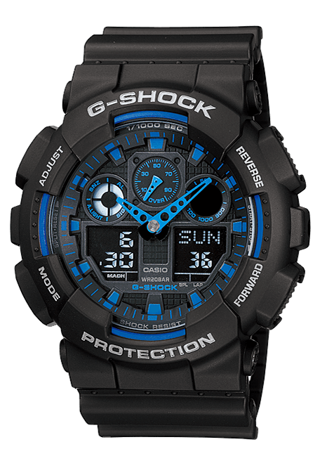

Casio G-Shock GA-100-1A2DR

Order online: 3.375.900 VND

List price : 3.751.000 VND

|  |  |
| --- | --- |
| **DETAILS**  **Brand** | **Casio** |
| **Place of origin** | **Japan** |
| **Product Line** | **G-SHOCK** |
| **Machine type** | **Quartz** |
| **Gender** | **Male** |
| **Diamete** | **55x51.2x16.9 mm** |
| **Case Material** | **Plastic** |
| **String material** | **Plastic** |
| **Glass material** | **Hard glass** |
| **Water Resistance** | **200m** |
| **Warranty international** | **1 year** |
| **Warranty at WATCH Time** | **3 years** |

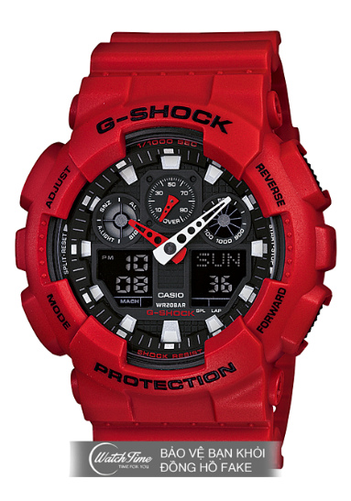

Casio G-Shock GA-100B-4ADR-TH

Order online: 3.379.500 VND

List price : 3.755.000 VND

|  |  |
| --- | --- |
| **DETAILS**  **Brand** | **Casio** |
| **Place of origin** | **Japan** |
| **Product Line** | **G-SHOCK** |
| **Machine type** | **Quartz** |
| **Gender** | **Male** |
| **Diamete** | **55×51,2×16,9mm** |
| **Case Material** | **Case Plastic** |
| **String material** | **Rubber band** |
| **Glass material** | **Hard glass** |
| **Water Resistance** | **200M** |
| **Warranty international** | **1 year** |
| **Warranty at WATCH Time** | **3 years** |

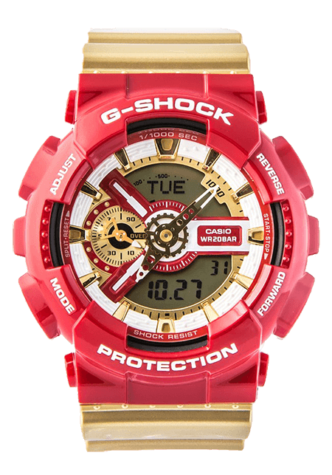

Casio G-Shock GA-110CS-4ADR

Order online: 3.808.800 VND

List price : 4.232.000 VND

|  |  |
| --- | --- |
| **DETAILS**  **Brand** | **Casio** |
| **Place of origin** | **Japan** |
| **Product Line** | **G-SHOCK** |
| **Machine type** | **Quartz** |
| **Gender** | **Male** |
| **Diamete** | **55x51.2x16.9 mm** |
| **Case Material** | **Plastic** |
| **String material** | **Plastic** |
| **Glass material** | **Hard glass** |
| **Water Resistance** | **200m** |
| **Warranty international** | **1 year** |
| **Warranty at WATCH Time** | **3 years** |

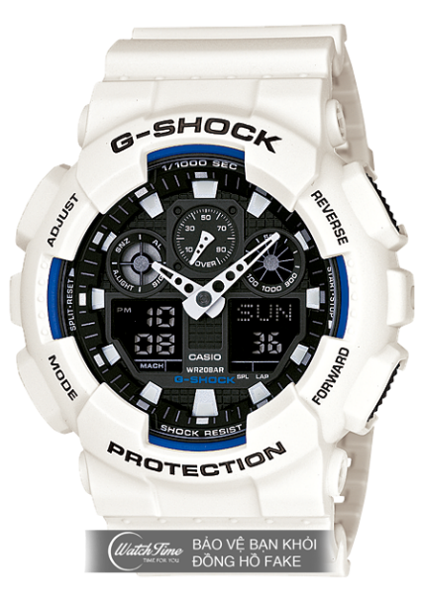

Casio G-Shock GA-100B-7ADR-TH

Order online: 3.379.500 VND

List price : 3.755.000 VND

|  |  |
| --- | --- |
| **DETAILS**  **Brand** | **Casio** |
| **Place of origin** | **Japan** |
| **Product Line** | **G-SHOCK** |
| **Machine type** | **Quartz** |
| **Gender** | **Male** |
| **Diamete** | **55 x 51,2 x 16,9mm** |
| **Case Material** | **Plastic** |
| **String material** | **Rubber band** |
| **Glass material** | **Hard glass** |
| **Water Resistance** | **200M** |
| **Warranty international** | **1 year** |
| **Warranty at WATCH Time** | **3 years** |

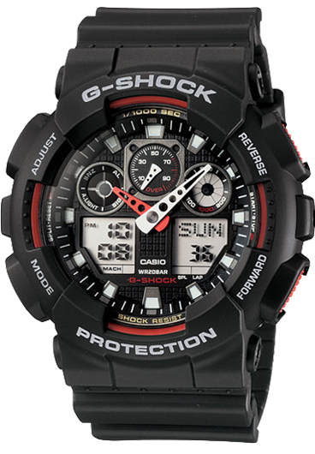

Casio G-Shock GA-100-1A4DR

Order online: 3.375.900 VND

List price : 3.751.000 VND

**Casio Female**

|  |  |
| --- | --- |
| **DETAILS**  **Brand** | **Casio** |
| **Item code** | **SHE-3046SGP-7AUDR** |
| **Place of origin** | **Japan** |
| **Product Line** | **Sheen** |
| **Machine type** | **Quarzt** |
| **Gender** | **Female** |
| **Diamete** | **40.9mm** |
| **Case Material** | **Stainless Steel** |
| **String material** | **Stainless Steel** |
| **Glass material** | **Glass Mineral** |
| **Water Resistance** | **50M** |
| **Warranty international** | **1 year** |
| **Warranty at WATCH TIME** | **3 years** |

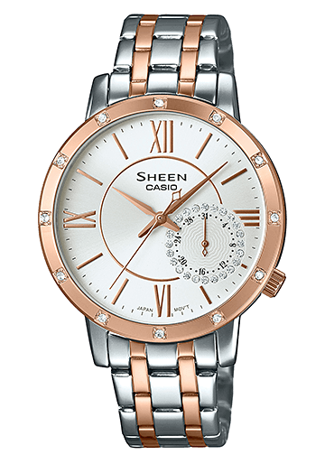

Casio SHE-3046SGP-7AUDR

Order online: 4.574.700 VND

List price : 5.083.000 VND

|  |  |
| --- | --- |
| **DETAILS**  **Brand** | **Casio** |
| **Item code** | **SHE-3047SG-7AUDR** |
| **Place of origin** | **Japan** |
| **Product Line** | **Sheen** |
| **Machine type** | **Quarzt** |
| **Gender** | **Female** |
| **Diamete** | **41,4×35,3×11,2mm** |
| **Case Material** | **Stainless Steel** |
| **String material** | **Stainless Steel** |
| **Glass material** | **Glass Mineral** |
| **Water Resistance** | **50M** |
| **Warranty international** | **1 year** |
| **Warranty at WATCH TIME** | **3 years** |

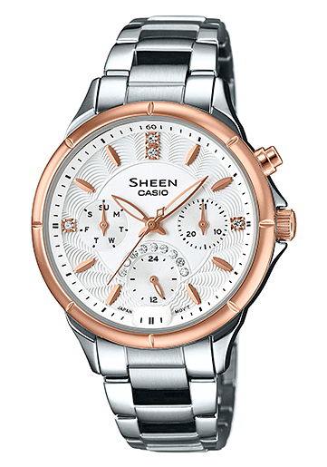

Casio SHE-3047SG-7AUDR

Order online: 3.808.800 VND

List price : 4.232.000 VND

|  |  |
| --- | --- |
| **DETAILS**  **Nhãn hiệu** | **Casio** |
| **Item code** | **SHE-3804GD-9AUDR** |
| **Place of origin** | **Japan** |
| **Product Line** | **Sheen** |
| **Machine type** | **Quarzt** |
| **Gender** | **Female** |
| **Diamete** | **32mm** |
| **Case Material** | **Stainless Steel** |
| **String material** | **Stainless Steel** |
| **Glass material** | **Glass Mineral** |
| **Water Resistance** | **50M** |
| **Warranty international** | **1 year** |
| **Warranty at WATCH TIME** | **3 years** |

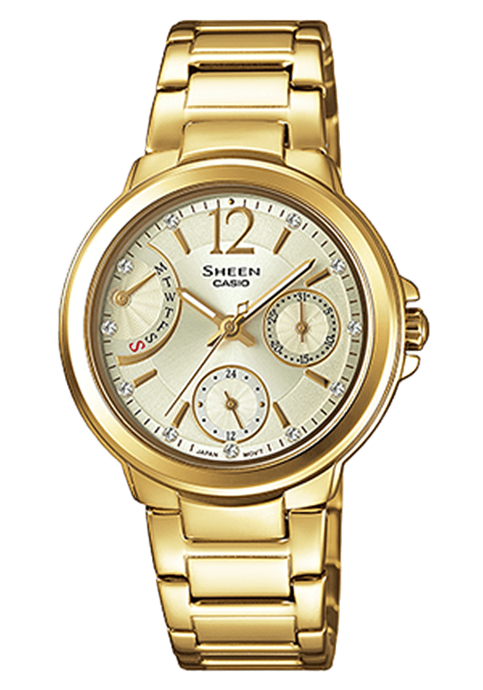   
Casio SHE-3804GD-9AUDR

Order online: 4.181.400 VND

List price : 4.646.000 VN

|  |  |
| --- | --- |
| **DETAILS**  **Brand** | **Casio** |
| **Place of origin** | **Japan** |
| **Product Line** | **Baby-G** |
| **Machine type** | **Quartz** |
| **Gender** | **Female** |
| **Diamete** | **44.7 × 39.8 × 14.6mm** |
| **Case Material** | **Case Plastic** |
| **String material** | **Rubber band** |
| **Glass material** | **Hard glass** |
| **Water Resistance** | **100M** |
| **Warranty international** | **1 year** |
| **Warranty at WATCH Time** | **3 years** |

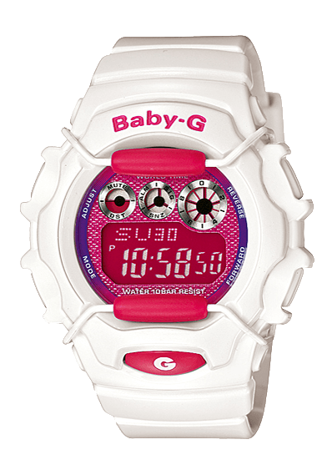

Casio BG-1006SA-7ADR

Order online: 2.566.800 VND

List price : 2.852.000 VND

|  |  |
| --- | --- |
| **Brand** | **Casio** |
| **Place of origin** | **Japan** |
| **Product Line** | **Baby-G** |
| **Machine type** | **Quartz** |
| **Gender** | **Female** |
| **Diamete** | **49,1 × 45 × 13,5mm** |
| **Case Material** | **Case Plastic** |
| **String material** | **Rubber band** |
| **Glass material** | **Hard glass** |
| **Water Resistance** | **200M** |
| **Warranty international** | **1 year** |
| **Warranty at WATCH Time** | **3 years** |

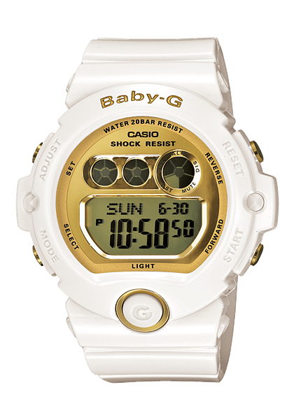

Casio BG-6901-7DR

Order online: 2.961.000 VND

List price : 3.290.000 VND

|  |  |
| --- | --- |
| **Nhãn hiệu** | **Casio** |
| **Item code** | **SHE-3046DP-7AUDR** |
| **Place of origin** | **Japan** |
| **Product Line** | **Sheen** |
| **Machine type** | **Quarzt** |
| **Gender** | **Female** |
| **Diamete** | **40.9mm** |
| **Case Material** | **Stainless Steel** |
| **String material** | **Stainless Steel** |
| **Glass material** | **Glass Mineral** |
| **Water Resistance** | **50M** |
| **Warranty international** | **1 year** |
| **Warranty at WATCH TIME** | **3 years** |

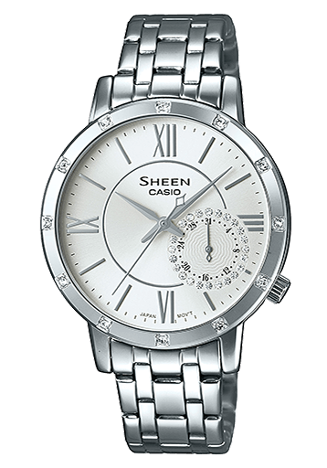

Casio SHE-3046DP-7AUDR

Order online: 3.415.500 VND

List price : 3.795.000 VND

WATCH ORIENT MALE

|  |  |
| --- | --- |
| **DETAILS**  **Brand** | **Orient** |
| **Place of origin** | **Japan** |
| **Product Line** | **Classics** |
| **Machine type** | **Automatic** |
| **Gender** | **Male** |
| **Diamete** | **41 mm** |
| **Case Material** | **Stainless Steel 316L** |
| **String material** | **Leather cord high-class** |
| **Glass material** | **Hard glass** |
| **Water Resistance** | **30M** |
| **Warranty international** | **1 year** |
| **Warranty at WATCH Time** | **3 years** |

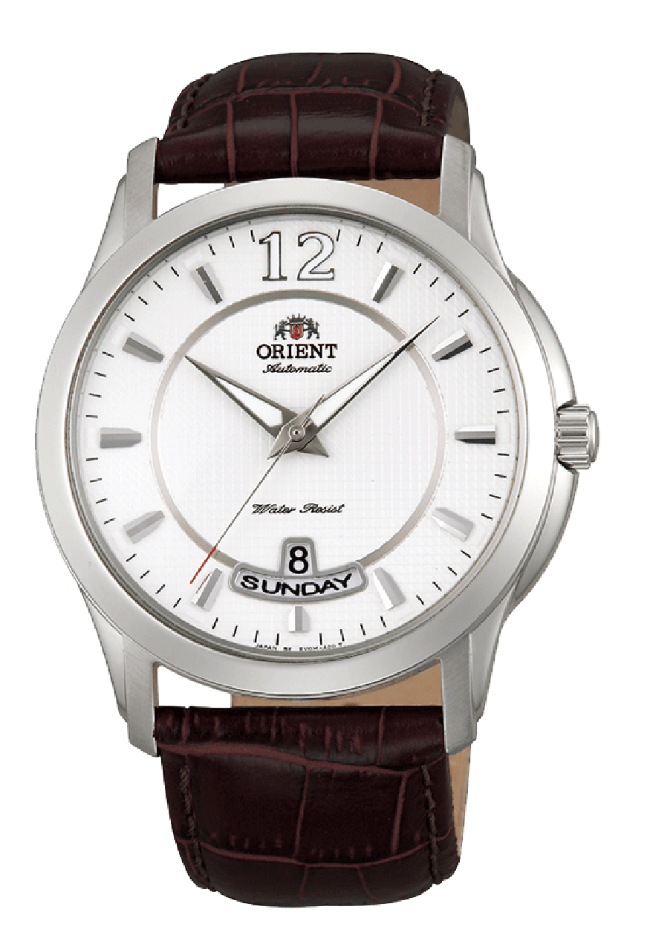

Orient FEV0M003WT

Order online: 3.285.000 VND

List price : 3.650.000 VND

|  |  |
| --- | --- |
| **DETAILS**  **Brand** | **Orient** |
| **Place of origin** | **Japan** |
| **Product Line** | **Classics** |
| **Machine type** | **Quartz** |
| **Gender** | **Male** |
| **Diamete** | **41mm** |
| **Case Material** | **Stainless Steel 316L/Plate PVD** |
| **String material** | **Stainless Steel 316L** |
| **Glass material** | **Hard glass** |
| **Water Resistance** | **50M** |
| **Warranty international** | **1 year** |
| **Warranty at WATCH Time** | **3 years** |

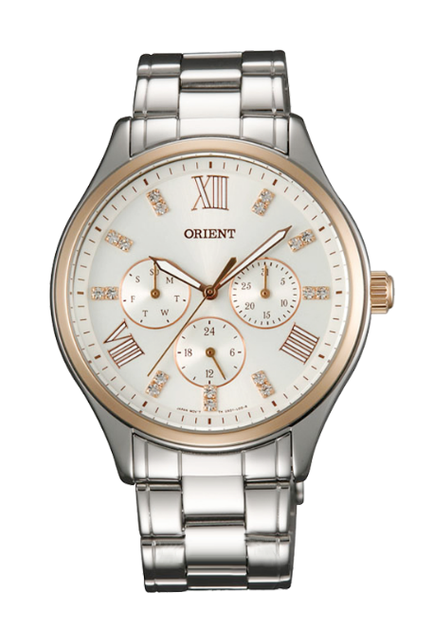

Orient FUX01004W0

Order online: 4.221.000 VND

List price : 4.690.000 VND

|  |  |
| --- | --- |
| **Brand** | **Orient** |
| **Place of origin** | **Japan** |
| **Product Line** | **Sporty** |
| **Machine type** | **Quartz** |
| **Gender** | **Male** |
| **Diamete** | **40mm** |
| **Case Material** | **Stainless Steel 316L** |
| **String material** | **Stainless Steel 316L** |
| **Glass material** | **Hard glass** |
| **Water Resistance** | **50M** |
| **Warranty international** | **1 year** |
| **Warranty at WATCH Time** | **3 years** |

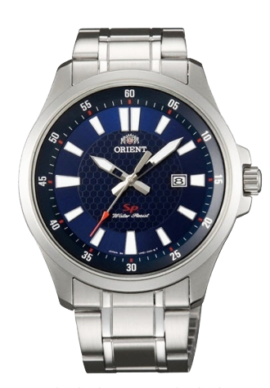

Orient FUNE1003D0

Order online: 1.800.000 VND

List price : 2.000.000 VND

|  |  |
| --- | --- |
| **Brand** | **Orient** |
| **Place of origin** | **Japan** |
| **Product Line** | **Classics** |
| **Machine type** | **Quartz** |
| **Gender** | **Male** |
| **Diamete** | **38mm** |
| **Case Material** | **Stainless Steel 316L** |
| **String material** | **Stainless Steel 316L** |
| **Glass material** | **Sapphire** |
| **Water Resistance** | **50M** |
| **Warranty international** | **1 year** |
| **Warranty at WATCH Time** | **3 years** |

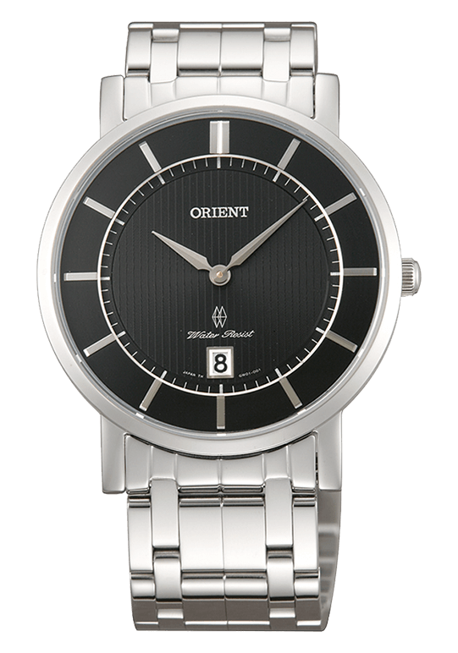

Orient Class FGW01005B0

Order online: 4.167.000 VND

List price : 4.630.000 VND

|  |  |
| --- | --- |
| **Brand** | **Orient** |
| **Place of origin** | **Japan** |
| **Product Line** | **Diving WATCH** |
| **Machine type** | **Automatic** |
| **Gender** | **Male** |
| **Diamete** | **41.5mm** |
| **Case Material** | **Stainless Steel 316L** |
| **String material** | **Stainless Steel 316L** |
| **Glass material** | **Hard glass** |
| **Water Resistance** | **200M** |
| **Warranty international** | **1 year** |
| **Warranty at WATCH Time** | **3 years**​ |

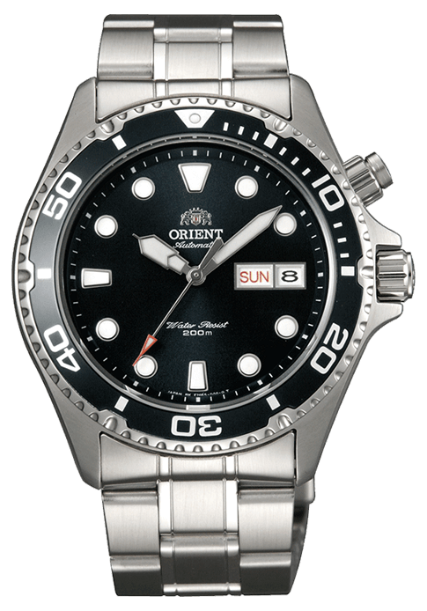

Orient Ray Black FEM65008B9 - Ray 1

Order online: 4.923.000 VND

List price : 5.470.000 VND

|  |  |
| --- | --- |
| **Brand** | **Orient** |
| **Place of origin** | **Japan** |
| **Product Line** | **Classics** |
| **Machine type** | **Automatic** |
| **Gender** | **Male** |
| **Diamete** | **41mm** |
| **Case Material** | **Stainless Steel 316L** |
| **String material** | **Stainless Steel 316L** |
| **Glass material** | **Glass Sapphire** |
| **Water Resistance** | **50M** |
| **Warranty international** | **1 year** |
| **Warranty at WATCH Time** | **3 years** |

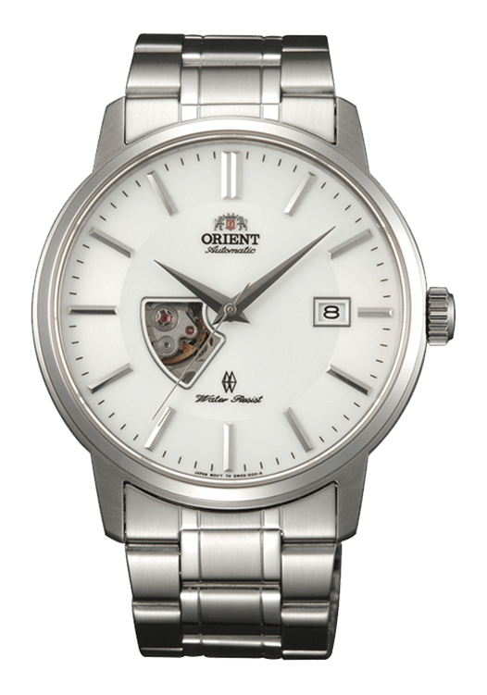

Orient EMINENCE FDW08003W0

Order online: 6.030.000 VND

List price : 6.700.000 VND

WATCH ORIENT Female

|  |  |
| --- | --- |
| **DETAILS**  **Brand** | **Orient** |
| **Place of origin** | **Japan** |
| **Product Line** | **Classic** |
| **Machine type** | **Automatic** |
| **Gender** | **Female** |
| **Diamete** | **36mm** |
| **Case Material** | **Stainless Steel 316L** |
| **String material** | **Leather cord** |
| **Glass material** | **Hard glass** |
| **Water Resistance** | **30M** |
| **Warranty international** | **1 year** |
| **Warranty at WATCH Time** | **3 years** |

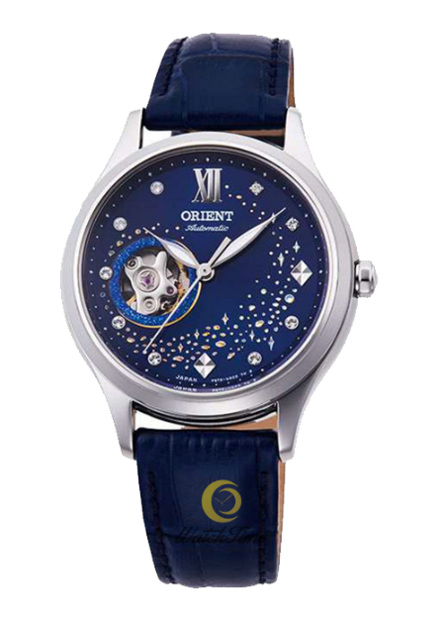

Orient RA-AG0018L10B

Order online: 6.210.000 VND

List price : 6.900.000 VND

|  |  |
| --- | --- |
| **Brand** | **Orient** |
| **Place of origin** | **Japan** |
| **Product Line** | **Classics** |
| **Machine type** | **Automatic** |
| **Gender** | **Female** |
| **Diamete** | **31mm** |
| **Case Material** | **Stainless Steel 316L/Plate PVD** |
| **String material** | **Stainless Steel 316L/Plate PVD** |
| **Glass material** | **Hard glass** |
| **Water Resistance** | **50M** |
| **Warranty international** | **1 year** |
| **Warranty at WATCH Time** | **3 years** |

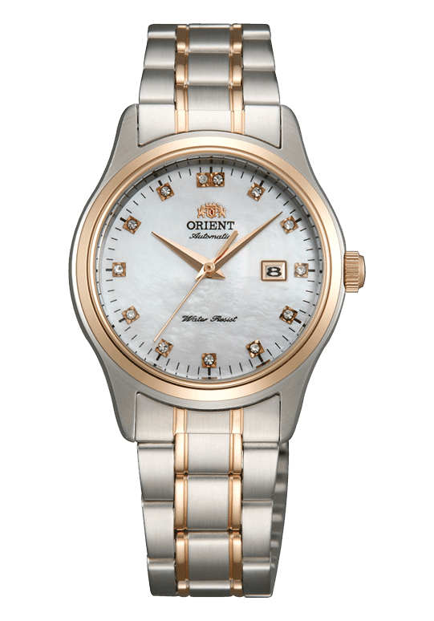

Orient Charlene FNR1Q001W0

Order online: 4.410.000 VND

List price : 4.900.000 VND

|  |  |
| --- | --- |
| **Brand** | **Orient** |
| **Place of origin** | **Japan** |
| **Product Line** | **Classics** |
| **Machine type** | **Automatic** |
| **Gender** | **Female** |
| **Diamete** | **35.5mm** |
| **Case Material** | **Stainless Steel 316L** |
| **String material** | **Stainless Steel 316L** |
| **Glass material** | **Hard glass** |
| **Water Resistance** | **50M** |
| **Warranty international** | **1 year** |
| **Warranty at WATCH Time** | **3 years** |

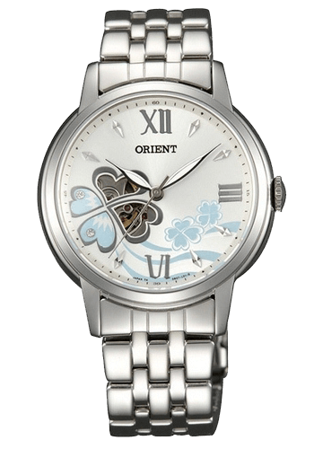

Orient Blossom DB07007D

Order online: 4.589.100 VND

List price : 5.099.000 VND

|  |  |
| --- | --- |
| **Brand** | **Orient** |
| **Place of origin** | **Japan** |
| **Product Line** | **Classics** |
| **Machine type** | **Automatic** |
| **Gender** | **Female** |
| **Diamete** | **31mm** |
| **Case Material** | **Stainless Steel 316L** |
| **String material** | **Stainless Steel 316L** |
| **Glass material** | **Hard glass** |
| **Water Resistance** | **50M** |
| **Warranty international** | **1 year** |
| **Warranty at WATCH Time** | **3 years** |

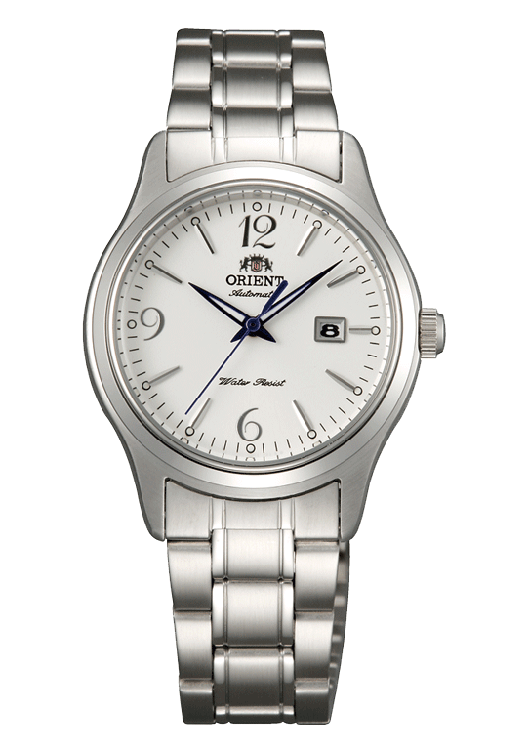

Orient Charlene FNR1Q005W0

Order online: 3.051.000 VND

List price : 3.390.000 VND

|  |  |
| --- | --- |
| **Brand** | **Orient** |
| **Place of origin** | **Japan** |
| **Product Line** | **Chronograph** |
| **Machine type** | **Quartz** |
| **Gender** | **Male** |
| **Diamete** | **42mm** |
| **Case Material** | **Stainless Steel 316L** |
| **String material** | **Stainless Steel 316L** |
| **Glass material** | **Hard glass** |
| **Water Resistance** | **100M** |
| **Warranty international** | **1 year** |
| **Warranty at WATCH Time** | **3 years** |

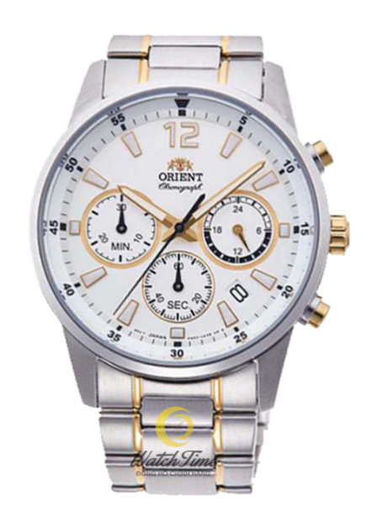

Orient Đồng-hồ-orient-RA-KV0003S10B

Order online: 5.886.000 VND

List price : 6.540.000 VND

|  |  |
| --- | --- |
| **Brand** | **Orient** |
| **Place of origin** | **Japan** |
| **Product Line** | **Classics** |
| **Machine type** | **Automatic** |
| **Gender** | **Female** |
| **Diamete** | **36 mm** |
| **Case Material** | **Stainless Steel 316L/Plate PVD** |
| **String material** | **Leather cord high-class** |
| **Glass material** | **Hard glass** |
| **Water Resistance** | **50M** |
| **Warranty international** | **1 year** |
| **Warranty at WATCH Time** | **3 years** |

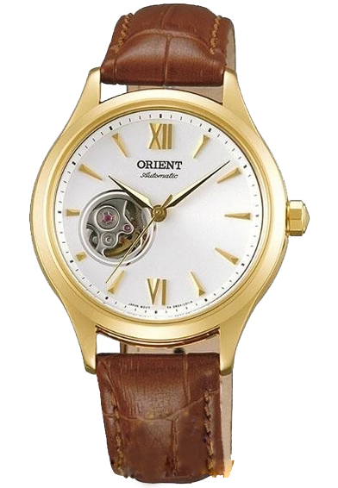

Orient FDB0A003W0

Order online: 5.067.000 VND

List price : 5.630.000 VND

WATCH SEIKO MALE

|  |  |
| --- | --- |
| **DETAILS**  **Brand** | **Seiko** |
| **Place of origin** | **Japan** |
| **Product Line** | **Seiko 5** |
| **Machine type** | **Automatic** |
| **Gender** | **Male** |
| **Diamete** | **42 mm** |
| **Case Material** | **Stainless Steel 316L** |
| **String material** | **Cloth rope Nato** |
| **Glass material** | **Glass Hardlex** |
| **Water Resistance** | **100M** |
| **Warranty international** | **1 year** |
| **Warranty at WATCH Time** | **3 years** |

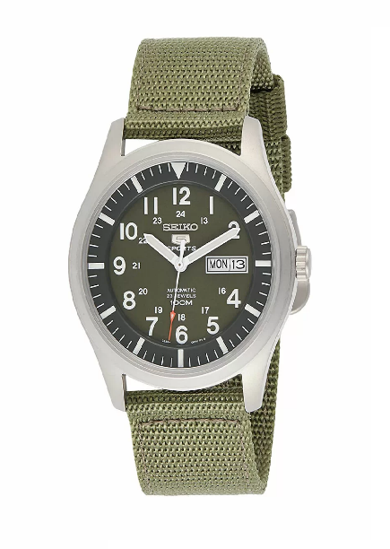

Seiko 5 Army SNZG09K1

Order online: 4.275.000 VND

List price : 4.750.000 VND

|  |  |
| --- | --- |
| **Brand** | **Seiko** |
| **Place of origin** | **Japan** |
| **Product Line** | **Seiko 5** |
| **Machine type** | **Automatic** |
| **Gender** | **Male** |
| **Diamete** | **37 mm** |
| **Case Material** | **Stainless Steel 316L** |
| **String material** | **Cloth rope Nato** |
| **Glass material** | **Glass Hardlex** |
| **Water Resistance** | **30M** |
| **Warranty international** | **1 year** |
| **Warranty at WATCH Time** | **3 years** |

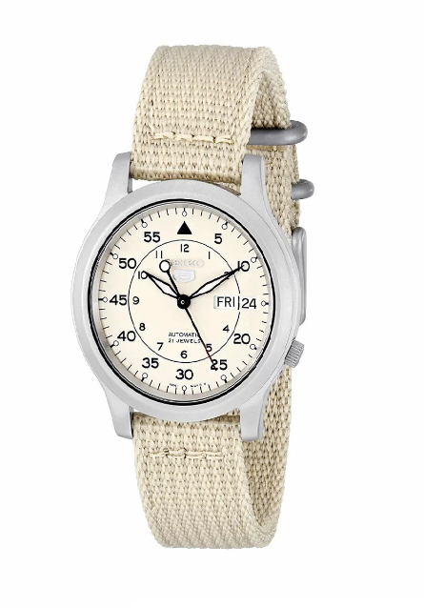

Seiko 5 Army SNK803K2

Order online: 2.690.000 VND

List price : 3.170.000 VND

|  |  |
| --- | --- |
|  |  |
| **Brand:**  **Place of origin :** | **Seiko**  **Japan** |
| **Machine type:** | **Kinetic** |
| **Glass material:** | **Sapphire** |
| **Diamete :** | **41.40mm** |
| **Case Material:** | **Stainless Steel Plate gold PVD** |
| **Case thickness:** | **11.95mm** |
| **String material:** | **Stainless Steel 316L** |
| **Water Resistance:** | **100m** |
| **Warranty genuine:** | **1 year international** |
|  |  |

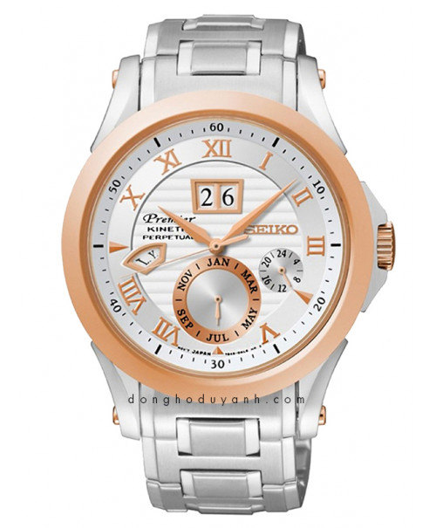

WATCH SEIKO PERPETUAL SNP080P1

Order online: 19.224.000 VND

List price : 21.360.000 VND

|  |  |
| --- | --- |
| **Brand:**  **Place of origin :**  **Machine type:** | **Seiko**  **Japan**  **Quartz** |
| **Glass material:** | **Sapphire** |
| **Diamete :** | **41.5mm** |
| **Case Material:** | **Stainless Steel Plate gold PVD** |
| **Case thickness:** | **11mm** |
| **String material:** | **Stainless Steel 316L** |
| **Water Resistance:** | **100m** |
| **Warranty genuine:** | **1 year international** |

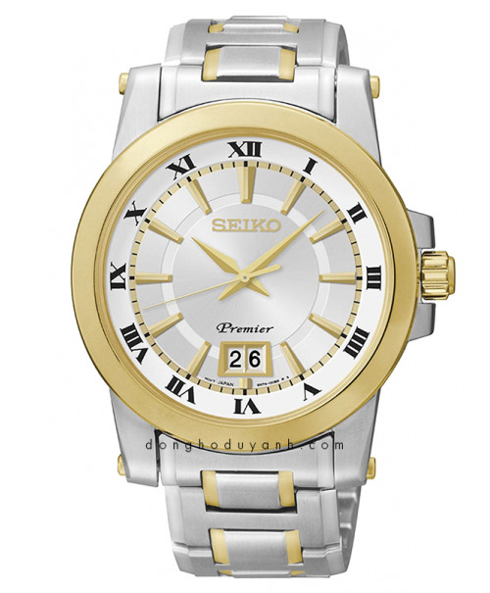

WATCH SEIKO SUR016P1

Order online: 8.591.400 VND

List price : 9.546.000 VND

|  |  |
| --- | --- |
| **Brand:**  **Place of origin:**  **Machine type:** | **Seiko**  **Japan**  **Quartz Solar** |
| **Glass material:** | **Sapphire** |
| **Diamete :** | **42.9mm** |
| **Case Material:** | **Stainless Steel 316L** |
| **Case thickness:** | **10.9mm** |
| **String material:** | **Stainless Steel 316L** |
| **Water Resistance:** | **100m** |
| **Warranty genuine:** | **1 year international** |
|  |  |

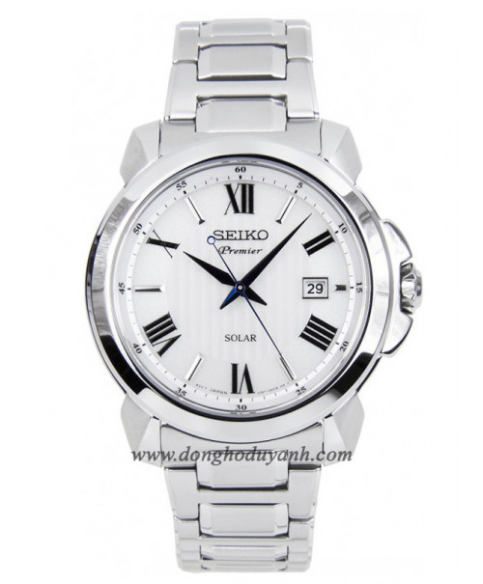

WATCH SEIKO SNE453P1

Order online: 9.405.000 VND

List price : 10.450.000 VND

|  |  |
| --- | --- |
| **Brand:**  **Machine type:** | **Seiko**  **Kinetic** |
| **Glass material:** | **Sapphire** |
| **Diamete :** | **41.5mm** |
| **Case Material:** | **Stainless Steel 316L** |
| **String material:** | **Leather cord** |
| **Water Resistance:** | **100m** |
| **Warranty genuine:** | **1 year international** |
| **Place of origin :** | **Japan** |

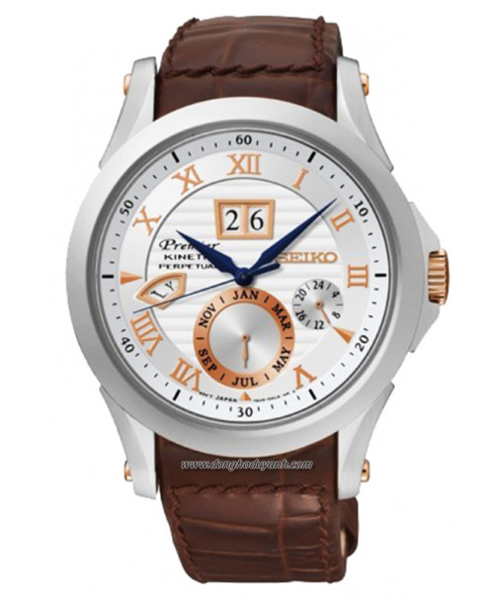

WATCH SEIKO PERPETUAL SNP082P1

Order online: 18.684.000  VND

List price : 20.760.000 VND

WATCH SEIKO Female

|  |  |
| --- | --- |
| **Brand:**  **Machine type:** | Seiko  Quartz |
| **Glass material:** | Hardlex Crystal |
| **Diamete :** | 26mm |
| **Case Material:** | Stainless Steel Plate gold PVD |
| **Case thickness:** | 6.9mm |
| **String material:** | Stainless Steel 316L Plate gold PVD |
| **Water Resistance:** | 30m |
| **Lug to Lug:** | 33mm |
| **Warranty genuine:** | 1 year international |
| **Place of origin :** | Japan |

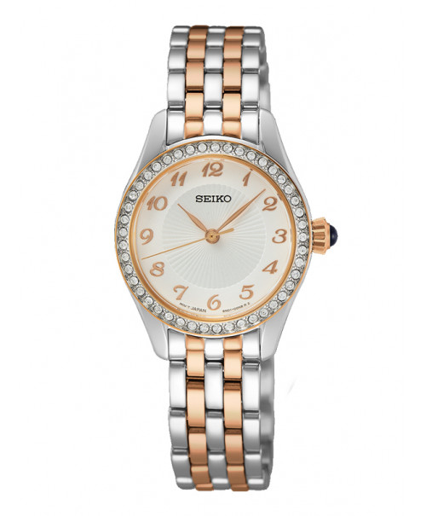

WATCH SEIKO SUR386P1

Order online: **7.378.000** VND

List price : 8.680.000 VND

|  |  |
| --- | --- |
| **Brand:**  **Machine type:** | **Seiko**  **Quartz Chronograph** |
| **Glass material:** | **Hardlex Crystal** |
| **Diamete :** | **26mm** |
| **Case Material:** | **Stainless Steel Plate gold PVD** |
| **Case thickness:** | **6.9mm** |
| **String material:** | **Stainless Steel 316L Plate gold PVD** |
| **Water Resistance:** | **30m** |
| **Lug to Lug:** | **33mm** |
| **Warranty genuine:** | **1 year international** |
| **Place of origin :** | **Japan** |

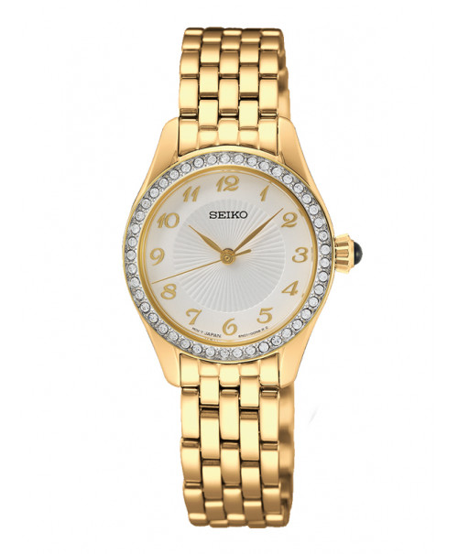

WATCH SEIKO SUR388P1

Order online: **7.378.000** VND

List price : 8.450.000 VND

|  |  |
| --- | --- |
| **Brand:**  **Machine type:** | **Seiko**  **Quartz Solar** |
| **Glass material:** | **Hardlex Crystal** |
| **Diamete :** | **30.5mm** |
| **Case Material:** | **Stainless Steel Plate gold PVD** |
| **Case thickness:** | **6.8mm** |
| **String material:** | **Leather cord** |
| **Water Resistance:** | **30m** |
| **Lug to Lug:** | **37.7mm** |
| **Warranty genuine:** | **1 year international** |
| **Place of origin :** | **Japan** |

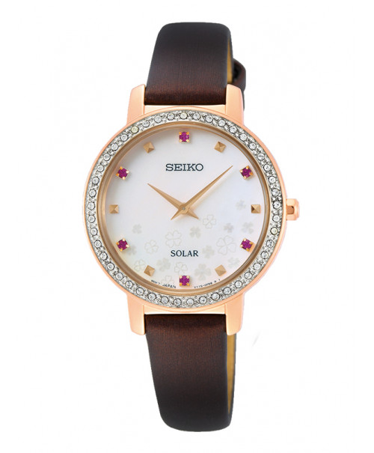

WATCH SEIKO SOLAR SUP450P1

Order online: **7.182.500** VND

List price : 8.450.000 VND

|  |  |
| --- | --- |
| **Brand:**  **Machine type:** | **Seiko**  **Quartz Solar** |
| **Glass material:** | **Hardlex Crystal** |
| **Diamete :** | **25mm** |
| **Case Material:** | **Stainless Steel Plate gold PVD** |
| **Case thickness:** | **6.3mm** |
| **String material:** | **Stainless Steel 316L Plate gold PVD** |
| **Water Resistance:** | **30m** |
| **Lug to Lug:** | **35.6mm** |
| **Warranty genuine:** | **1 year international** |
| **Place of origin :** | **Japan** |

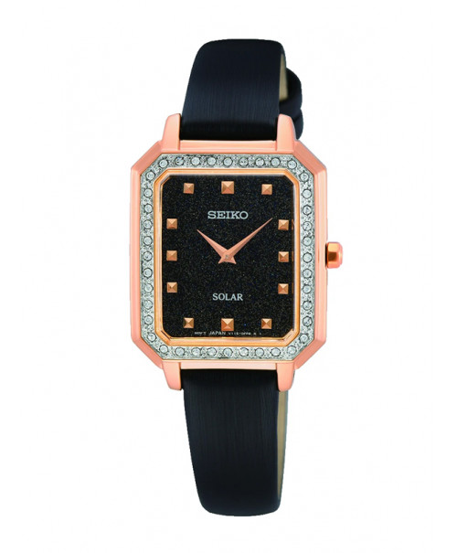

WATCH SEIKO SOLAR SUP446P1

Order online: **7.182.500** VND

List price : 8.450.000 VND

|  |  |
| --- | --- |
| **Brand:**  **Machine type:** | **Seiko**  **Quartz** |
| **Glass material:** | **Hardlex Crystal** |
| **Diamete :** | **34mm** |
| **Case Material:** | **Stainless Steel 316L** |
| **String material:** | **Stainless Steel 316L** |
| **Water Resistance:** | **30m** |
| **Warranty genuine:** | **1 year international** |
| **Place of origin** | **Japan** |

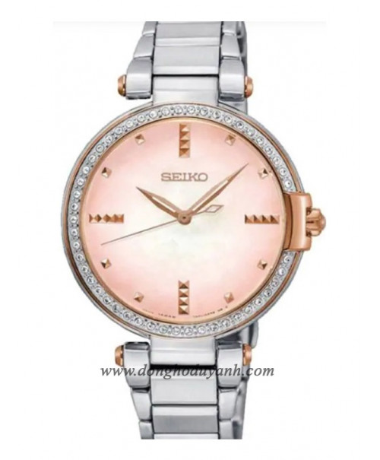

WATCH SEIKO SRZ514P1

Order online: **6.528.000**  VND

|  |  |
| --- | --- |
| **Brand:**  **Machine type:** | **Seiko**  **Quartz** |
| **Glass material:** | **Hardlex Crystal** |
| **Diamete :** | **33mm** |
| **Case Material:** | **Stainless Steel Plate gold PVD** |
| **Case thickness:** | **8mm** |
| **String material:** | **Stainless Steel 316L Plate gold PVD** |
| **Water Resistance:** | **30m** |
| **Warranty genuine:** | **1 year international** |
| **Place of origin:** | **Japan** |

List price : 7.680.000 VND

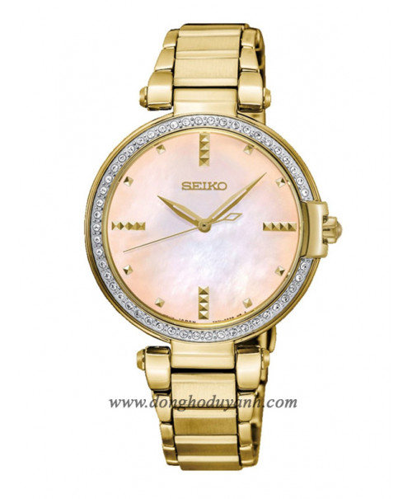

WATCH SEIKO SRZ518P1

Order online: **6.817.000**VND

List price : 8.020.000 VND

|  |  |
| --- | --- |
| **Brand:**  **Machine type:** | **Tissot**  **Quartz** |
| **Glass material:** | **Sapphire** |
| **Diamete :** | **40mm** |
| **Case Material:** | **Stainless Steel 316L** |
| **Case thickness:** | **10.4mm** |
| **String material:** | **Stainless Steel 316L** |
| **Size cable:** | **12mm** |
| **Water Resistance:** | **100m** |
| **Lug to Lug:** | **46mm** |
| **Warranty genuine:** | **2 years international** |
| **Place of origin :** | **Switzerland** |

WATCH Tissot Male

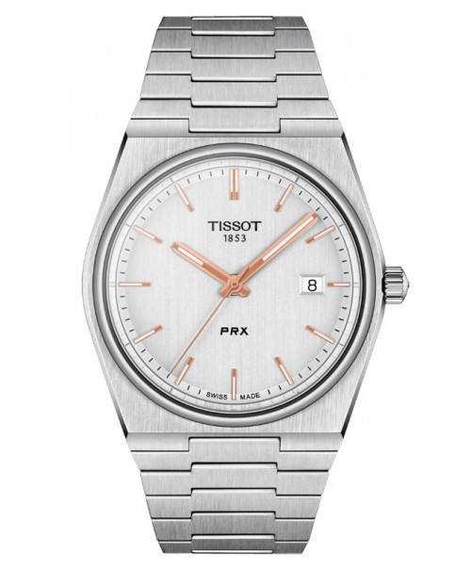

TISSOT PRX T137.410.11.031.00

Order online: **9.234.000** VND

|  |  |
| --- | --- |
| **Machine type:** | **Automatic** |
| **Glass material:** | **Sapphire** |
| **Diamete :** | **40mm** |
| **Case Material:** | **Stainless Steel Plate gold PVD** |
| **Case thickness:** | **10.9mm** |
| **String material:** | **Stainless Steel 316L** |
| **Size cable:** | **12mm** |
| **Water Resistance:** | **100m** |
| **Lug to Lug:** | **46mm** |
| **Warranty genuine:** | **2 years international** |
| **Place of origin:** | **Switzerland** |

List price : 10.260.000 VND

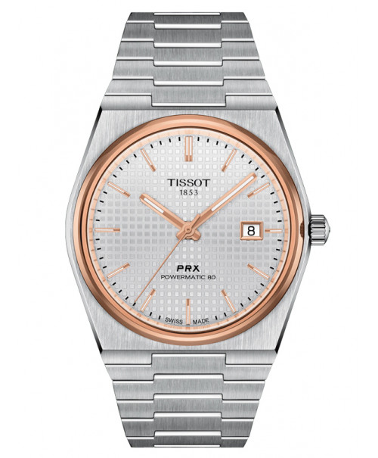

TISSOT PRX POWERMATIC 80

T137.407.21.031.00

Order online: **9.234.000** VND

List price : 10.260.000 VND

|  |  |
| --- | --- |
| **Machine type:** | **Automatic** |
| **Glass material:** | **Sapphire** |
| **Diamete :** | **40mm** |
| **Case Material:** | **Stainless Steel 316L** |
| **Case thickness:** | **11.5mm** |
| **String material:** | **Stainless Steel 316L** |
| **Size cable:** | **21mm** |
| **Water Resistance:** | **100m** |
| **Lug to Lug:** | **50mm** |
| **Warranty genuine:** | **2 years international** |
| **Place of origin:** | **Switzerland** |

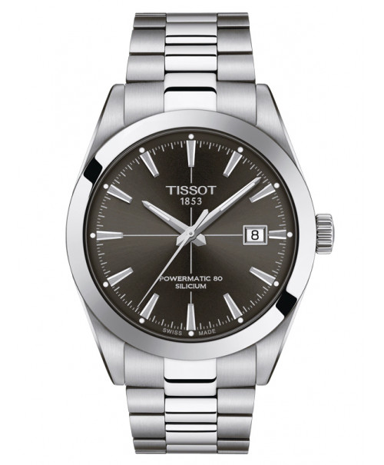

TISSOT GENTLEMAN POWERMATIC 80

SILICIUM T127.407.11.061.01

Order online: **19.261.000**VND

List price : 22.660.000 VND

|  |  |
| --- | --- |
| **Machine type:** | **Automatic** |
| **Glass material:** | **Sapphire** |
| **Diamete :** | **40mm** |
| **Case Material:** | **Stainless Steel 316L** |
| **Case thickness:** | **11.5mm** |
| **String material:** | **Leather cord** |
| **Water Resistance:** | **100m** |
| **Warranty genuine:** | **2 years international** |
| **Place of origin:** | **Switzerland** |

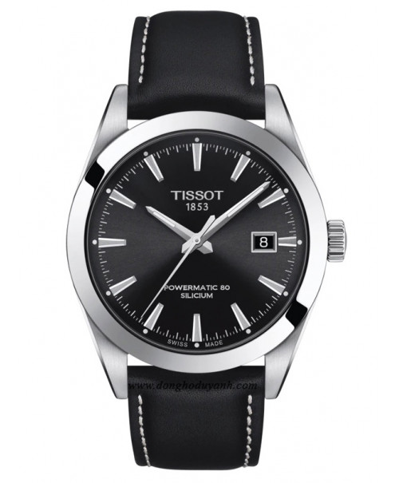

TISSOT GENTLEMAN POWERMATIC

80 SILICIUM T127.407.16.051.00

Order online: **17.841.500** VND

List price : 20.990.000 VND

|  |  |
| --- | --- |
| **Machine type:** | **Quartz** |
| **Glass material:** | **Sapphire** |
| **Diamete :** | **40mm** |
| **Case Material:** | **Stainless Steel Plate gold PVD** |
| **Case thickness:** | **7mm** |
| **String material:** | **Stainless Steel 316L Plate gold PVD** |
| **Size cable:** | **20mm** |
| **Water Resistance:** | **50m** |
| **Warranty genuine:** | **2 years international** |
| **Place of origin:** | **Switzerland** |

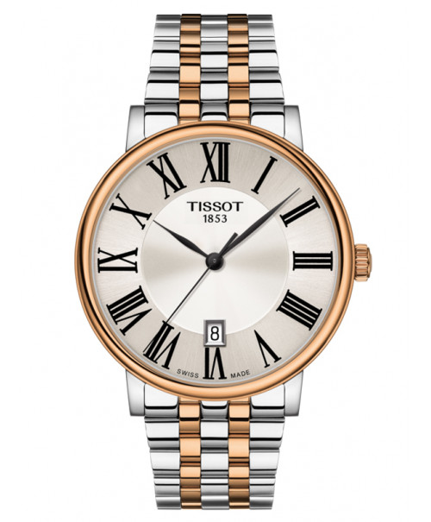

TISSOT CARSON PREMIUM

T122.410.22.033.00

Order online: **10.344.500** VND

List price : 12.170.000 VND

WATCH Tissot Female

|  |  |
| --- | --- |
| **Machine type:** | **Quartz** |
| **Glass material:** | **Sapphire** |
| **Diamete :** | **30mm** |
| **Case Material:** | **Stainless Steel Plate gold PVD** |
| **Case thickness:** | **6.2mm** |
| **String material:** | **Stainless Steel 316L Plate gold PVD** |
| **Water Resistance:** | **30m** |
| **Warranty genuine:** | **2 years International** |
| **Place of origin:** | **Switzerland** |

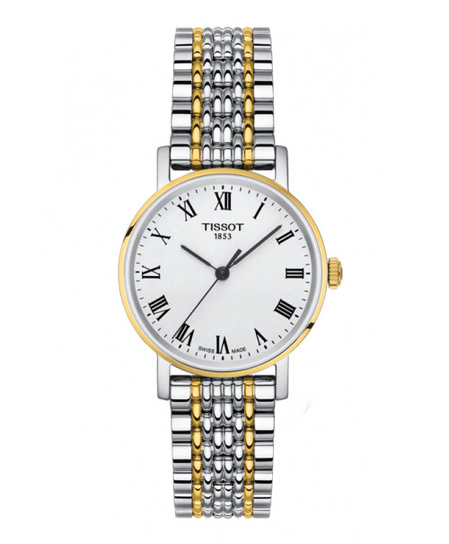

TISSOT EVERYTIME

T109.210.22.033.00

Order online: **6.213.500**VND

List price : 7.310.000 VND

|  |  |
| --- | --- |
| **Machine type:** | **Quartz** |
| **Glass material:** | **Sapphire** |
| **Diamete :** | **33mm x 33mm** |
| **Case Material:** | **Stainless Steel 316L** |
| **Case thickness:** | **9mm** |
| **String material:** | **Leather cord** |
| **Water Resistance:** | **100m** |
| **Warranty genuine:** | **2 years international** |
| **Place of origin:** | **Switzerland** |

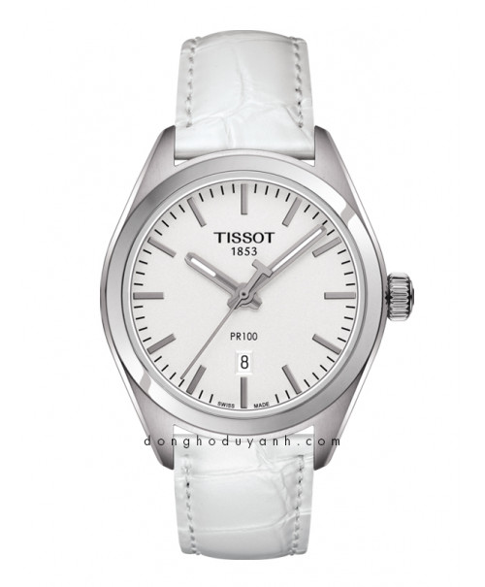

TISSOT PR 100 T101.210.16.031.00

Order online: **6.104.000**VND

List price : 7.630.000 VND

|  |  |
| --- | --- |
| **Machine type:** | **Quartz** |
| **Glass material:** | **Sapphire** |
| **Diamete :** | **28mm** |
| **Case Material:** | **Stainless Steel 316L** |
| **Case thickness:** | **7.4mm** |
| **String material:** | **Stainless Steel 316L** |
| **Size cable:** | **14mm** |
| **Water Resistance:** | **30m** |
| **Warranty genuine:** | **2 years international** |
| **Place of origin:** | **Switzerland** |

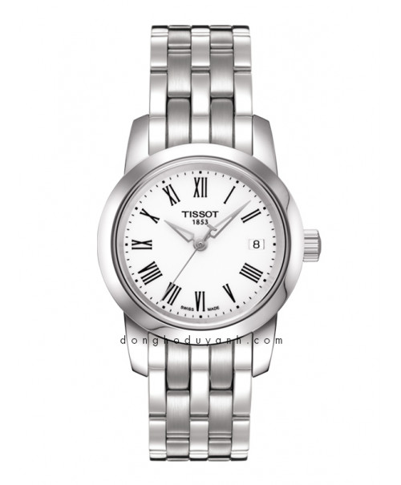

TISSOT CLASSIC DREAM

T033.210.11.013.00

Order online: **6.086.000** VND

List price : 7.160.000 VND

|  |  |
| --- | --- |
| **Machine type:** | **Automatic** |
| **Glass material:** | **Sapphire** |
| **Diamete :** | **29mm** |
| **Case Material:** | **Stainless Steel 316L/ Gold 18K** |
| **Case thickness:** | **10.4mm** |
| **String material:** | **Stainless Steel 316L** |
| **Size cable:** | **15mm** |
| **Water Resistance:** | **50m** |
| **Warranty genuine:** | **2 years international** |
| **Place of origin:** | **Switzerland** |

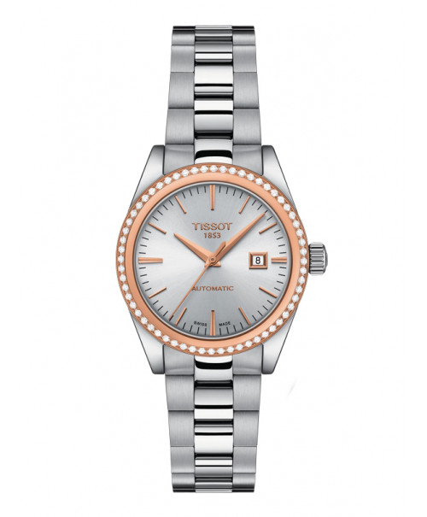

WATCH TISSOT T-MY LADY

AUTOMATIC 18K GOLD T930.007.41.031.00

Order online: **51.697.000** VND

List price : 60.820.000 VND

|  |  |
| --- | --- |
| **Machine type:** | **Quartz** |
| **Glass material:** | **Sapphire** |
| **Diamete :** | **30mm** |
| **Case Material:** | **Stainless Steel Plate gold PVD** |
| **Case thickness:** | **6.15mm** |
| **String material:** | **Stainless Steel 316L Plate gold PVD** |
| **Water Resistance:** | **30m** |
| **Warranty genuine:** | **2 years International** |

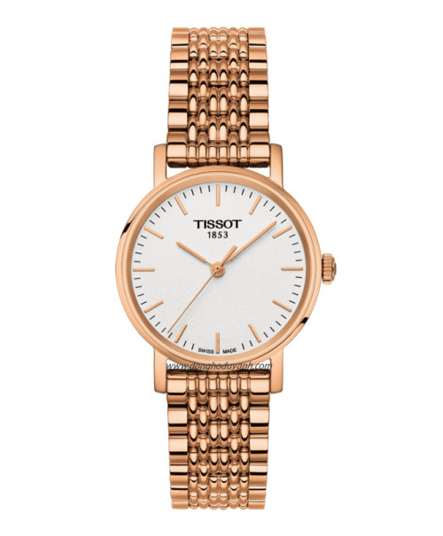

TISSOT EVERYTIME T109.210.33.031.00

Order online: **6.468.500** VND

List price : 7.610.000 VND

WATCH Mido Male

|  |  |
| --- | --- |
| **Machine type:** | **Automatic Chronometer** |
| **Glass material:** | **Sapphire** |
| **Diamete :** | **40mm** |
| **Case Material:** | **Stainless Steel 316L** |
| **Case thickness:** | **9.43mm** |
| **String material:** | **Stainless Steel 316L** |
| **Water Resistance:** | **30m** |
| **Lug to Lug:** | **47mm** |
| **Warranty genuine:** | **3 years international** |
| **Place of origin:** | **Switzerland** |

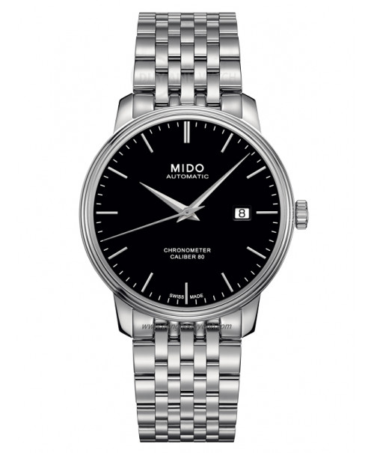

MIDO BARONCELLI III AUTOMATIC

M027.408.11.051.00

Order online: **26.299.000** VND

List price : 30.940.000 VND

|  |  |
| --- | --- |
| **Machine type:** | **Automatic Chronometer** |
| **Glass material:** | **Sapphire** |
| **Diamete :** | **40mm** |
| **Case Material:** | **Stainless Steel 316L** |
| **Case thickness:** | **9.43mm** |
| **String material:** | **Stainless Steel 316L** |
| **Water Resistance:** | **30m** |
| **Lug to Lug:** | **47mm** |
| **Warranty genuine:** | **3 years international** |
| **Place of origin:** | **Switzerland** |

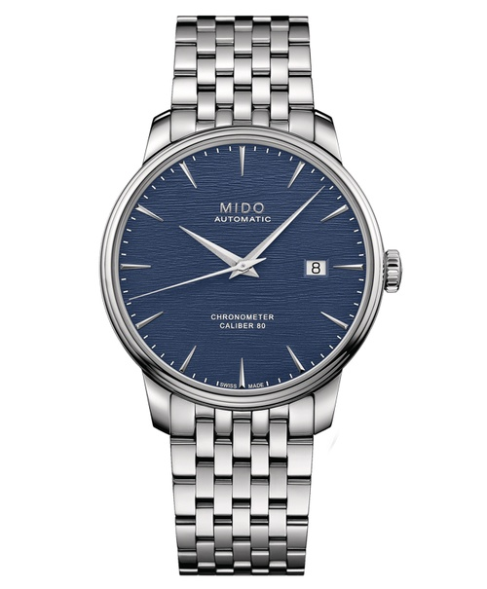

MIDO BARONCELLI CHRONOMETER

SILICON M027.408.11.041.00

Order online: **26.299.000** VND

List price : 30.940.000 VND

|  |  |
| --- | --- |
| **Machine type:** | Automatic Chronometer |
| **Glass material:** | Sapphire |
| **Diamete :** | 40mm |
| **Case Material:** | Stainless Steel 316L |
| **Case thickness:** | 9.43mm |
| **String material:** | Stainless Steel 316L |
| **Water Resistance:** | 30m |
| **Lug to Lug:** | 47mm |
| **Warranty genuine:** | 3 years international |
| **Place of origin:** | **Switzerland** |

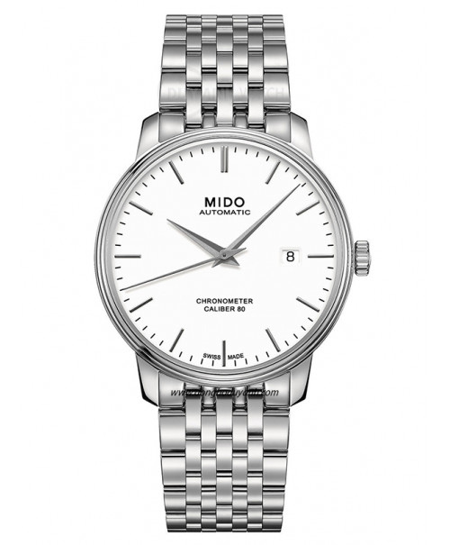

MIDO BARONCELLI III AUTOMATIC

M027.408.11.011.00

Order online: **26.299.000** VND

List price : 30.940.000 VND

|  |  |
| --- | --- |
| **Machine type:** | **Automatic** |
| **Glass material:** | **Sapphire** |
| **Diamete :** | **42mm** |
| **Case Material:** | **Stainless Steel 316L** |
| **Case thickness:** | **9.85mm** |
| **String material:** | **Leather cord** |
| **Water Resistance:** | **50m** |
| **Warranty genuine:** | **2 years international** |
| **Place of origin:** | **Switzerland** |

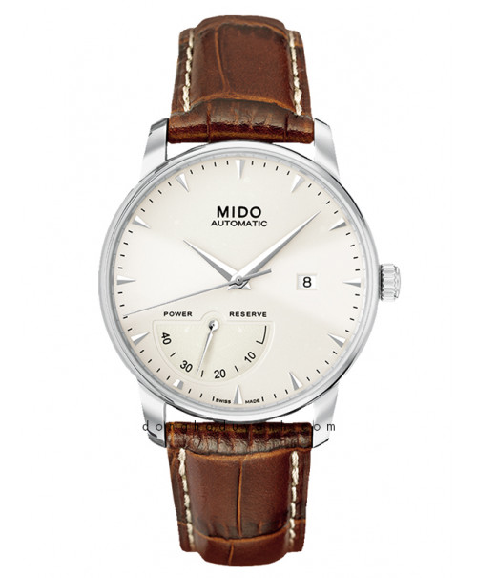

WATCH MIDO M8605.4.11.8

Order online: **25.599.000** VND

List price : 36.570.000 VND

|  |  |
| --- | --- |
| **Machine type:** | **Automatic Chronometer** |
| **Glass material:** | **Sapphire** |
| **Diamete :** | **40mm** |
| **Case Material:** | **Stainless Steel 316L** |
| **Case thickness:** | **9.43mm** |
| **String material:** | **Leather cord** |
| **Water Resistance:** | **30m** |
| **Lug to Lug:** | **47mm** |
| **Warranty genuine:** | **3 years international** |
| **Place of origin:** | **Thụy Sĩ** |

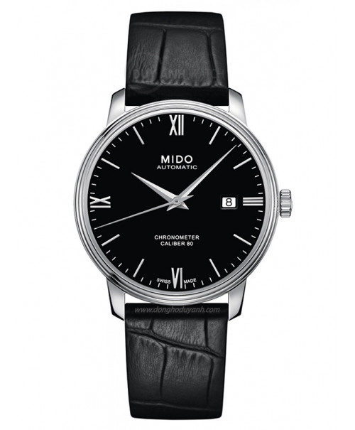

MIDO BARONCELLI III AUTOMATIC

M027.408.16.058.00

Order online: **24.862.500**VND

List price : 29.250.000 VND

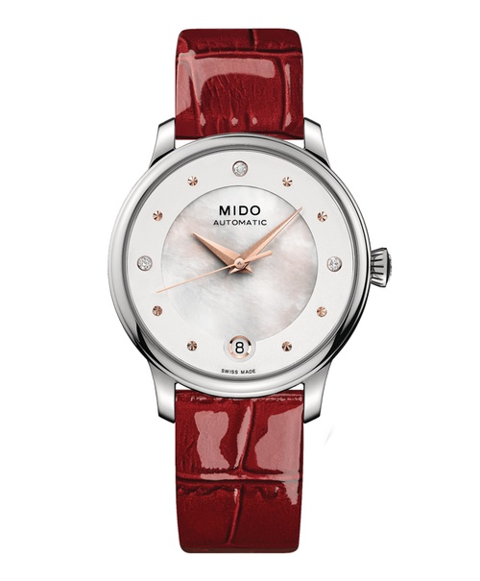WATCH Mido Female

|  |  |
| --- | --- |
| **Machine type:** | **Automatic** |
| **Glass material:** | **Sapphire** |
| **Diamete :** | **33mm** |
| **Case Material:** | **Stainless Steel 316L** |
| **Case thickness:** | **9.9mm** |
| **String material:** | **Leather cord** |
| **Size cable:** | **16mm** |
| **Water Resistance:** | **50m** |
| **Warranty genuine:** | **2 years international** |
| **Place of origin:** | **Switzerland** |

WATCH MIDO BARONCELLI

LADY DAY NIGHT M039.207.16.106.00

Order online: **21.513.500**VND

List price : 25.310.000 VND

|  |  |
| --- | --- |
| **Machine type:** | **Automatic** |
| **Glass material:** | **Sapphire** |
| **Diamete :** | **33mm** |
| **Case Material:** | **Stainless Steel Plate gold PVD** |
| **Case thickness:** | **7.15mm** |
| **String material:** | **Leather cord** |
| **Size cable:** | **17mm** |
| **Water Resistance:** | **30m** |
| **Warranty genuine:** | **2 years international** |
| **Place of origin:** | **Switzerland** |

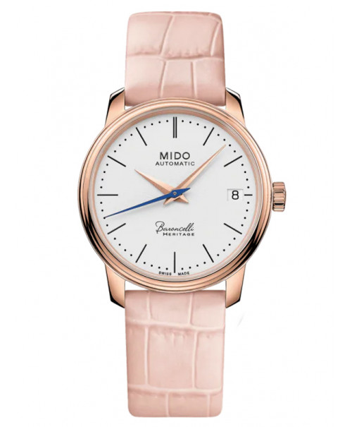

MIDO BARONCELLI HERITAGE

M027.207.36.010.00

|  |  |
| --- | --- |
| **Machine type:** | **Automatic** |
| **Glass material:** | **Sapphire** |
| **Diamete :** | **33mm** |
| **Case Material:** | **Stainless Steel Plate gold PVD** |
| **Case thickness:** | **9.83mm** |
| **String material:** | **Stainless Steel 316L Plate gold PVD** |
| **Size cable:** | **16mm** |
| **Water Resistance:** | **50m** |
| **Warranty genuine:** | **2 years international** |
| **Place of origin:** | **Switzerland** |

Order online: **24.157.000**VND

List price : 28.420.000 VND

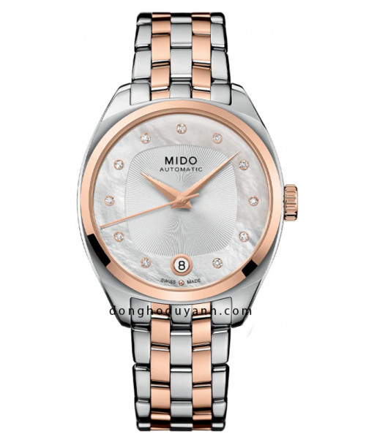

MIDO BELLUNA ROYAL LADY

M024.307.22.116.00

Order online: **22.474.000** VND

List price : 26.440.000 VND

|  |  |
| --- | --- |
| **Machine type:** | **Automatic** |
| **Glass material:** | **Sapphire** |
| **Diamete :** | **33mm** |
| **Case Material:** | **Stainless Steel 316L** |
| **Case thickness:** | **9.83mm** |
| **String material:** | **Leather cord** |
| **Size cable:** | **16mm** |
| **Water Resistance:** | **50m** |
| **Warranty genuine:** | **2 years international** |
| **Place of origin:** | **Switzerland** |

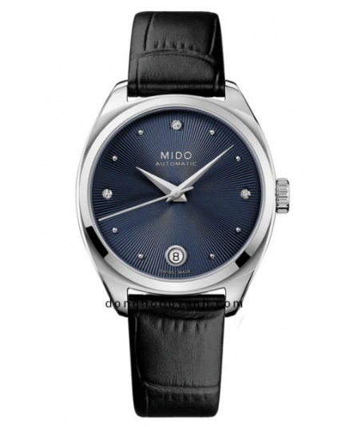

MIDO BELLUNA ROYAL LADY

M024.307.16.046.00

Order online: **16.983.000**VND

List price : 19.980.000 VND

|  |  |
| --- | --- |
| **Machine type:** | **Automatic** |
| **Glass material:** | **Sapphire** |
| **Diamete :** | **33mm** |
| **Case Material:** | **Stainless Steel 316L** |
| **Case thickness:** | **9.83mm** |
| **String material:** | **Stainless Steel 316L** |
| **Size cable:** | **16** |
| **Water Resistance:** | **50m** |
| **Warranty genuine:** | **2 years international** |
| **Place of origin:** | **Switzerland** |

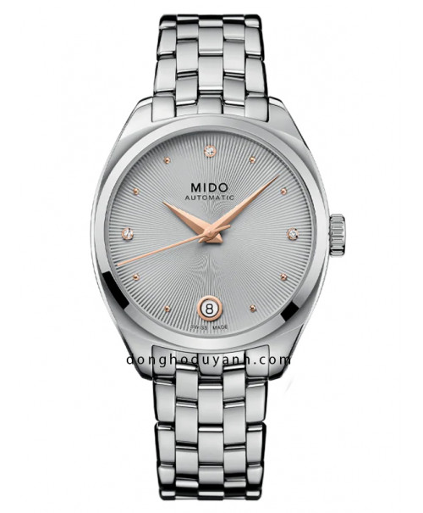

MIDO BELLUNA ROYAL LADY

M024.307.11.076.00

Order online: **18.419.500**VND

List price : 21.670.000 VND

WATCH citizen Male

|  |  |
| --- | --- |
| **Machine type:** | **Automatic** |
| **Glass material:** | **Glass material cứng** |
| **Diamete :** | **40mm** |
| **Case Material:** | **Stainless Steel Plate PVD** |
| **Case thickness:** | **13.1mm** |
| **String material:** | **Stainless Steel Plate PVD** |
| **Size cable:** | **20mm** |
| **Water Resistance:** | **50m** |
| **Lug to Lug:** | **46mm** |
| **Warranty genuine:** | **1 year international** |
| **Place of origin:** | **Japan** |

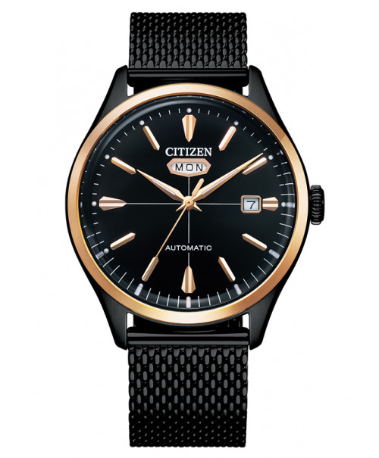

WATCH CITIZEN C7 NH8396-82E

Order online: **7.800.450**VND

List price : 9.177.000 VND

|  |  |
| --- | --- |
| **Machine type:** | **Automatic** |
| **Glass material:** | **Glass material cứng** |
| **Diamete :** | **40mm** |
| **Case Material:** | **Stainless Steel Plate PVD** |
| **Case thickness:** | **13.1mm** |
| **String material:** | **Leather cord** |
| **Size cable:** | **20mm** |
| **Water Resistance:** | **50m** |
| **Lug to Lug:** | **46mm** |
| **Warranty genuine:** | **1 year international** |
| **Place of origin:** | **Japan** |

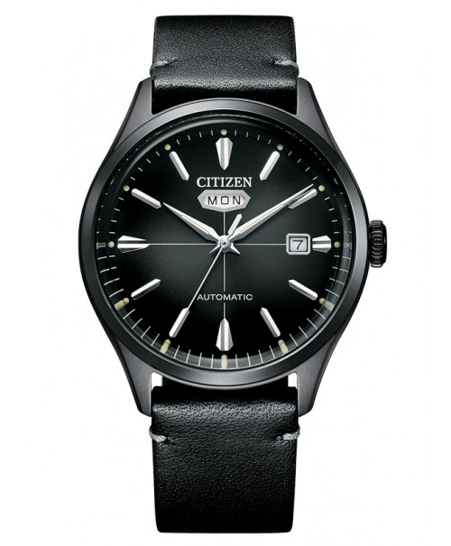

WATCH CITIZEN C7 NH8395-00E

Order online: **7.715.450**VND

List price : 9.077.000 VND

|  |  |
| --- | --- |
| **Machine type:** | **Automatic** |
| **Glass material:** | **Glass material cứng** |
| **Diamete :** | **40mm** |
| **Case Material:** | **Stainless Steel 316L** |
| **Case thickness:** | **13.1mm** |
| **String material:** | **Stainless Steel 316L Plate gold PVD** |
| **Size cable:** | **20mm** |
| **Water Resistance:** | **50m** |
| **Lug to Lug:** | **46mm** |
| **Warranty genuine:** | **1 year international** |
| **Place of origin:** | **Japan** |

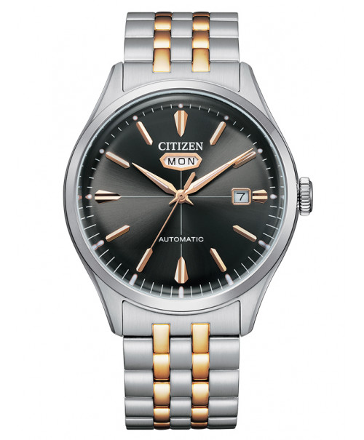

WATCH CITIZEN C7 NH8394-70H

Order online: **7.800.450**VND

List price : 9.177.000 VND

|  |  |
| --- | --- |
| **Machine type:** | **Automatic** |
| **Glass material:** | **Glass material cứng** |
| **Diamete :** | **40mm** |
| **Case Material:** | **Stainless Steel Plate gold PVD** |
| **Case thickness:** | **13.1mm** |
| **String material:** | **Leather cord** |
| **Size cable:** | **20mm** |
| **Water Resistance:** | **50m** |
| **Lug to Lug:** | **46mm** |
| **Warranty genuine:** | **1 year international** |
| **Place of origin:** | **Japan** |

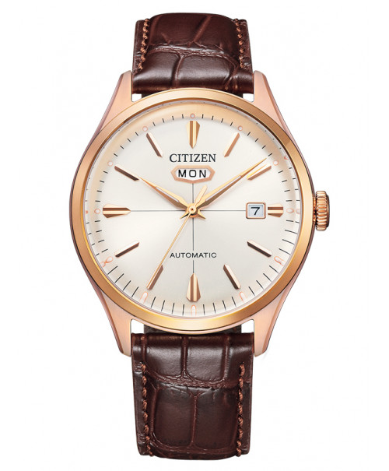

WATCH CITIZEN C7 NH8393-05A

Order online: **7.120.450** VND

List price : 8.377.000 VND

|  |  |
| --- | --- |
| **Machine type:** | Automatic |
| **Glass material:** | Glass material cứng |
| **Diamete :** | 40mm |
| **Case Material:** | Stainless Steel 316L |
| **Case thickness:** | 13.1mm |
| **String material:** | Stainless Steel 316L dạng lưới |
| **Size cable:** | 20mm |
| **Water Resistance:** | 50m |
| **Lug to Lug:** | 46mm |
| **Warranty genuine:** | 1 year international |
| **Place of origin:** | Japan |

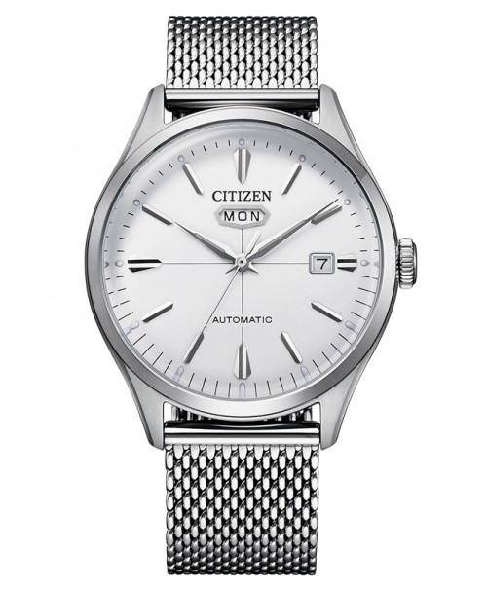

WATCH CITIZEN C7 NH8390-89A

Order online: **6.695.450** VND

List price : 7.877.000 VND

WATCH citizen Female

|  |  |
| --- | --- |
| **Machine type:** | Quartz |
| **Glass material:** | Glass material cứng |
| **Diamete :** | 24mm |
| **Case Material:** | Stainless Steel Plate gold PVD |
| **Case thickness:** | 6.7mm |
| **String material:** | Stainless Steel 316L Plate gold PVD |
| **Water Resistance:** | 30m |
| **Warranty genuine:** | 1 year international |
| **Place of origin:** | Japan |

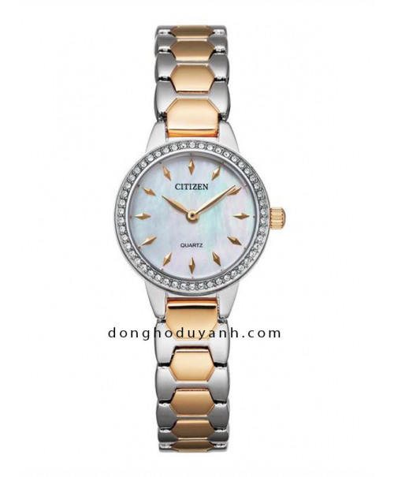

WATCH CITIZEN EZ7016-50D

Order online: **3.664.000** VND

List price : 4.580.000 VND

|  |  |
| --- | --- |
| **Machine type:** | **Quartz** |
| **Glass material:** | **Glass material cứng** |
| **Diamete :** | **30mm** |
| **Case Material:** | **Stainless Steel 316L** |
| **Case thickness:** | **7mm** |
| **String material:** | **Stainless Steel 316L Plate gold PVD** |
| **Size cable:** | **14mm** |
| **Water Resistance:** | **50m** |
| **Warranty genuine:** | **1 year international** |
| **Place of origin:** | **Japan** |

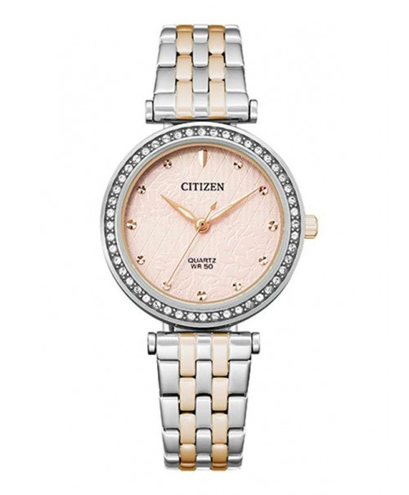

WATCH CITIZEN ER0218-53X

Order online: **3.568.000** VND

List price : 4.460.000 VND

|  |  |
| --- | --- |
| **Machine type:** | **Eco-Drive** |
| **Glass material:** | **Glass material cứng** |
| **Diamete :** | **25mm** |
| **Case Material:** | **Stainless Steel Plate gold PVD** |
| **Case thickness:** | **7.3mm** |
| **String material:** | **Stainless Steel 316L Plate gold PVD** |
| **Water Resistance:** | **50m** |
| **Warranty genuine:** | **1 year international** |
| **Place of origin:** | **Japan** |

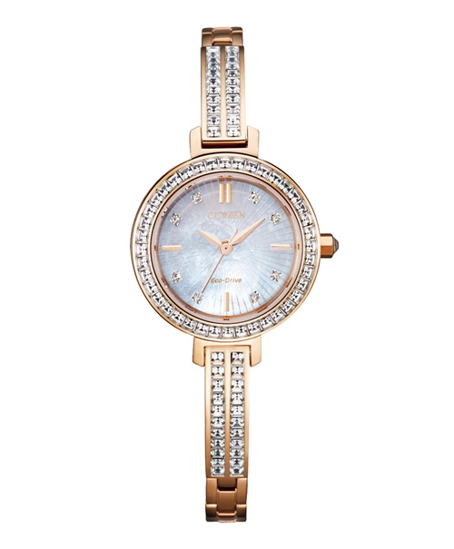

CITIZEN ECO-DRIVE EM0863-53D

Order online: **8.448.000**VND

List price : 10.560.000 VND

|  |  |
| --- | --- |
| **Machine type:** | **Eco-Drive** |
| **Glass material:** | **Glass material cứng** |
| **Diamete :** | **32mm** |
| **Case Material:** | **Stainless Steel Plate gold PVD** |
| **Case thickness:** | **7.3mm** |
| **String material:** | **Stainless Steel 316L Plate gold PVD** |
| **Water Resistance:** | **50m** |
| **Warranty genuine:** | **1 year international** |
| **Place of origin:** | **Japan** |

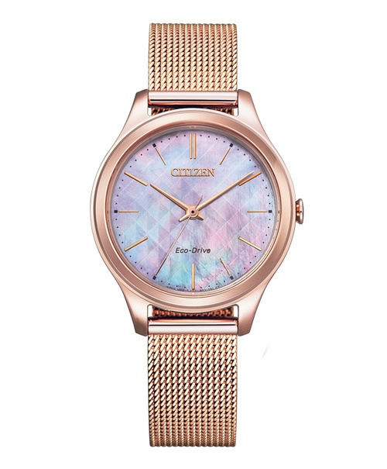

CITIZEN ECO-DRIVE EM0508-80Y

Order online: **4.928.000** VND

List price : 6.160.000 VND

|  |  |
| --- | --- |
| **Machine type:** | **Automatic** |
| **Glass material:** | **Sapphire** |
| **Diamete :** | **34mm** |
| **Case Material:** | **Stainless Steel Plate gold PVD** |
| **String material:** | **Leather cord** |
| **Water Resistance:** | **100m** |
| **Warranty genuine:** | **1 year international** |
| **Place of origin:** | **Japan** |

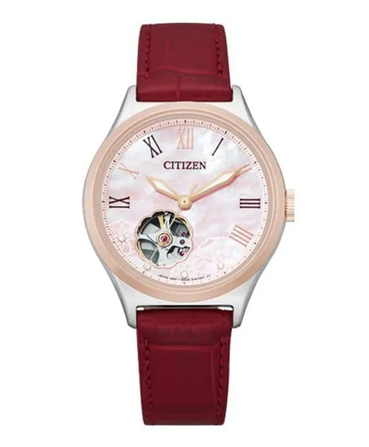

CITIZEN AUTOMATIC PC1008-11Y

Order online: **7.392.000** VND

List price : 9.240.000 VND

|  |  |
| --- | --- |
| WATCH CASE | Stainless steel |
| CASE DIAMETER | 30.5 mm |
| CASE HEIGHT | 7 mm |
| WATER RESISTANCE | 5 ATM (shower-proof) |
| ADJUSTMENT RANGE | Wrist circumference of 145-190 mm |
| GENDER | Female |
| SWISS MADE | Hand-assembled in Switzerland |
| COLOR | Steel / Light Blue Mother-of-Pearl |
| REFERENCE | J5.642.M |

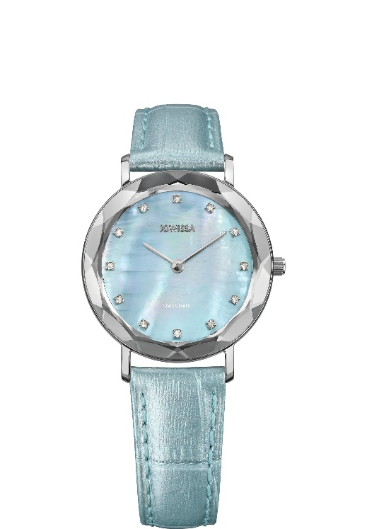

[Aura Swiss Ladies J5.642.M](https://www.jowissa.com/products/aura-steel-light-blue-mother-of-pearl-leather-j5-642-m)

[€219.90](https://www.jowissa.com/products/aura-steel-light-blue-mother-of-pearl-leather-j5-642-m)

**Aura Female**

|  |  |
| --- | --- |
| WATCH CASE | Stainless steel |
| CASE DIAMETER | 30.5 mm |
| CASE HEIGHT | 7 mm |
| WATER RESISTANCE | 5 ATM (shower-proof) |
| ADJUSTMENT RANGE | Wrist circumference of 145-190 mm |
| GENDER | Female |
| SWISS MADE | Hand-assembled in Switzerland |
| COLOR | Rose / Black Rose Gradation |
| REFERENCE | J5.648.M |

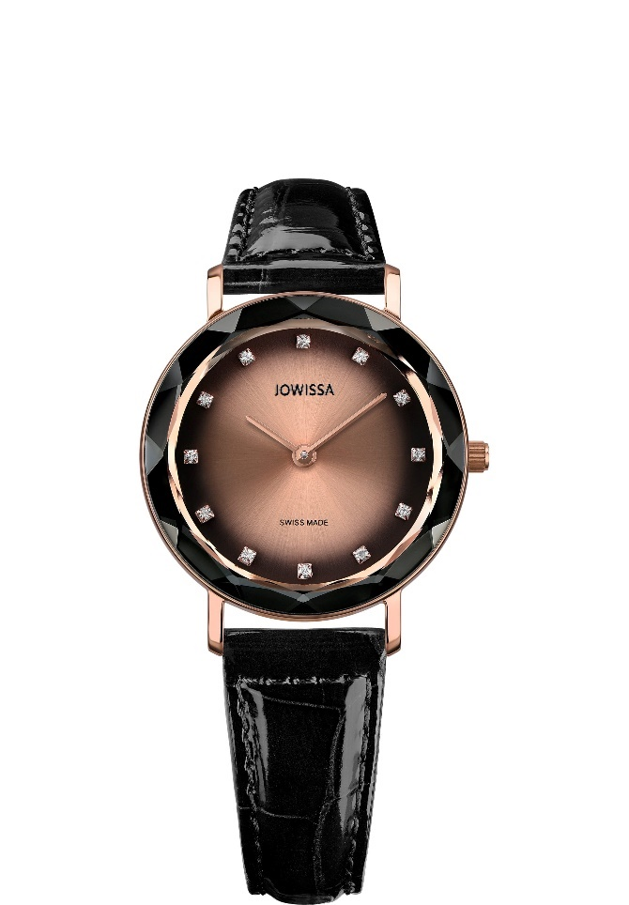

[**Aura Swiss Ladies J5.648.M**](https://www.jowissa.com/products/aura-rose-black-rose-gradation-leather-j5-648-m)

€229.90

|  |  |
| --- | --- |
| WATCH CASE | Stainless steel |
| CASE DIAMETER | 39 mm |
| CASE HEIGHT | 7 mm |
| WATER RESISTANCE | 3 ATM (shower-proof) |
| ADJUSTMENT RANGE | Wrist circumference of 160-215 mm |
| GENDER | Female |
| SWISS MADE | Hand-assembled in Switzerland |
| COLOR | Rose / White |
| REFERENCE | J5.562.L |

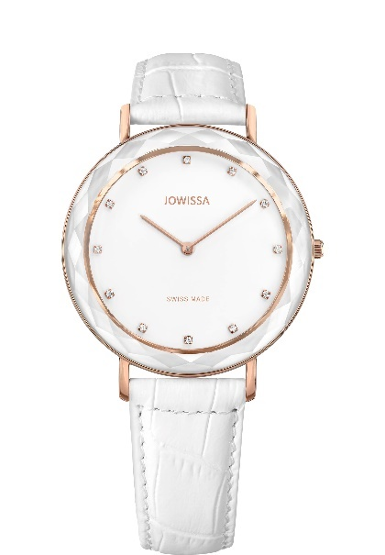

[Aura Swiss Ladies J5.562.L](https://www.jowissa.com/products/aura-swiss-ladies-watch-j5-562-l)

€219.90

|  |  |
| --- | --- |
| WATCH CASE | Stainless steel |
| CASE DIAMETER | 39 mm |
| CASE HEIGHT | 7 mm |
| WATER RESISTANCE | 3 ATM (shower-proof) |
| ADJUSTMENT RANGE | Wrist circumference of 160-215 mm |
| GENDER | Female |
| SWISS MADE | Hand-assembled in Switzerland |
| COLOR | Rose / Grey |
| REFERENCE | J5.566.L |

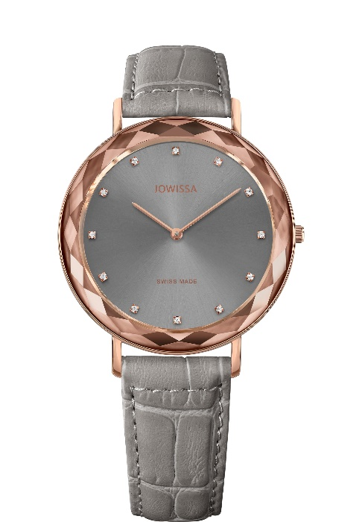

[Aura Swiss Ladies J5.566.L](https://www.jowissa.com/products/aura-swiss-ladies-watch-j5-566-l)

€219.90

|  |  |
| --- | --- |
| WATCH CASE | Stainless steel |
| CASE DIAMETER | 26 x 30 mm |
| CASE HEIGHT | 7.4 mm |
| WATER RESISTANCE | 5 ATM (shower-proof) |
| ADJUSTMENT RANGE | Wrist circumference of 120-200 mm |
| GENDER | Female |
| SWISS MADE | Hand-assembled in Switzerland |
| COLOR | Gold / Bordeaux |
| REFERENCE | J8.082.M |

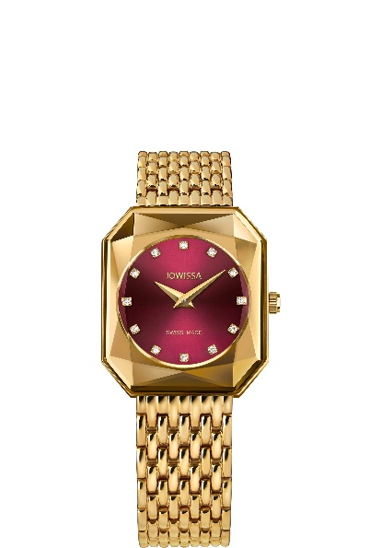

[Facet Radiant Swiss Ladies WATCH J8.082.M](https://www.jowissa.com/products/facet-radiant-swiss-ladies-watch-j8-082-m)

€269.90

|  |  |
| --- | --- |
| WATCH CASE | Stainless steel |
| CASE DIAMETER | 26 x 30 mm |
| CASE HEIGHT | 7.4 mm |
| WATER RESISTANCE | 5 ATM (shower-proof) |
| ADJUSTMENT RANGE | Wrist circumference of 120-200 mm |
| INTERCHANGEABLE BAND | Yes |
| GENDER | Female |
| SWISS MADE | Hand-assembled in Switzerland |
| COLOR | Gold / Blue |
| REFERENCE | J8.080.M |

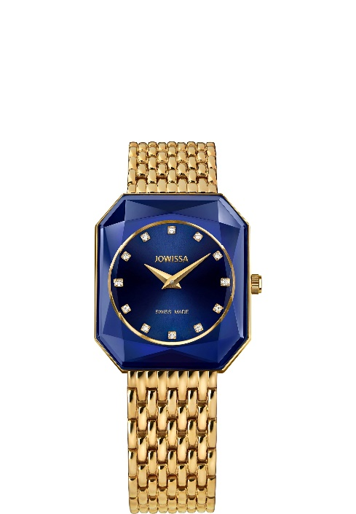

[Facet Radiant J8.080.M](https://www.jowissa.com/products/facet-radiant-swiss-ladies-watch-j8-080-m)

€269.90

|  |  |
| --- | --- |
| WATCH CASE | Stainless steel |
| CASE DIAMETER | 35 mm |
| CASE HEIGHT | 6 mm |
| WATER RESISTANCE | 5 ATM (shower-proof) |
| ADJUSTMENT RANGE | Wrist circumference of 165-215 mm |
| GENDER | Female |
| SWISS MADE | Hand-assembled in Switzerland |
| COLOR | Gold / Brown |
| REFERENCE | J6.317.L |

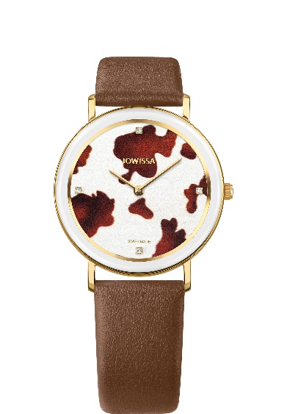

[AnWy Swiss Ladies WATCH J6.317.L](https://www.jowissa.com/products/anwy-swiss-ladies-watch-j6-317-l)

€219.90

|  |  |
| --- | --- |
| WATCH CASE | Stainless steel |
| CASE DIAMETER | 35 mm |
| CASE HEIGHT | 6 mm |
| WATER RESISTANCE | 5 ATM (shower-proof) |
| ADJUSTMENT RANGE | Wrist circumference of 165-215 mm |
| GENDER | Female |
| SWISS MADE | Hand-assembled in Switzerland |
| COLOR | Rose / White / Brown |
| REFERENCE | J6.222.L |

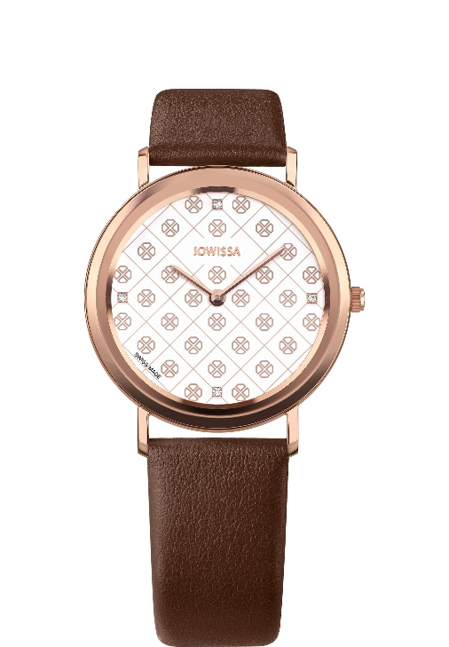

[AnWy Swiss Ladies WATCH J6.222.L](https://www.jowissa.com/products/anwy-swiss-ladies-watch-j6-222-l)

€219.90

|  |  |
| --- | --- |
| WATCH CASE | Stainless steel |
| CASE DIAMETER | 30.5 mm |
| CASE HEIGHT | 6 mm |
| WATER RESISTANCE | 5 ATM (shower-proof) |
| ADJUSTMENT RANGE | Wrist circumference of 150-195 mm |
| GENDER | Female |
| SWISS MADE | Hand-assembled in Switzerland |
| COLOR | Steel / White |
| REFERENCE | J4.395.M |

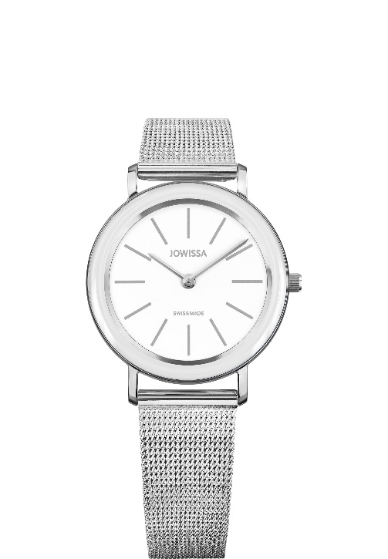

[Alto Swiss Ladies WATCH J4.395.M](https://www.jowissa.com/products/alto-steel-white-mesh-j4-395-m)

€219.90

|  |  |
| --- | --- |
| WATCH CASE | Stainless steel |
| CASE DIAMETER | 38 mm |
| CASE HEIGHT | 10 mm |
| WATER RESISTANCE | 5 ATM (shower-proof) |
| ADJUSTMENT RANGE | Wrist circumference of 165-215 mm |
| GENDER | Female |
| SWISS MADE | Hand-assembled in Switzerland |
| COLOR | Gold / White / Red |
| REFERENCE | J6.233.M |

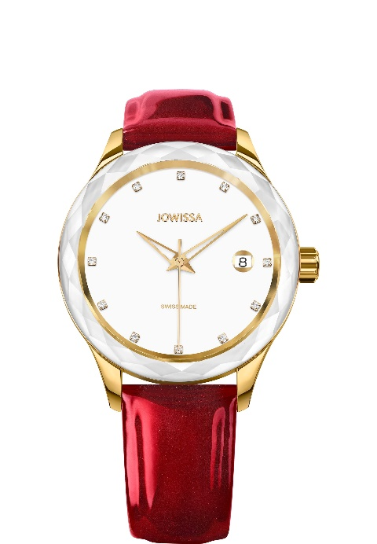

[Tiro Swiss Ladies WATCH J6.233.M](https://www.jowissa.com/products/tiro-swiss-ladies-watch-j6-233-m)

€229.90

|  |  |
| --- | --- |
| WATCH CASE | Stainless Steel Case with Pavé Set Rhinestones |
| CASE DIAMETER | 29.5 mm |
| CASE HEIGHT | 9 mm |
| WATER RESISTANCE | 5 ATM (shower-proof) |
| ADJUSTMENT RANGE | Wrist circumference of 120-205 mm |
| GENDER | Female |
| SWISS MADE | Hand-assembled in Switzerland |
| COLOR | Rose / Bordeaux |
| REFERENCE | J5.714.M |

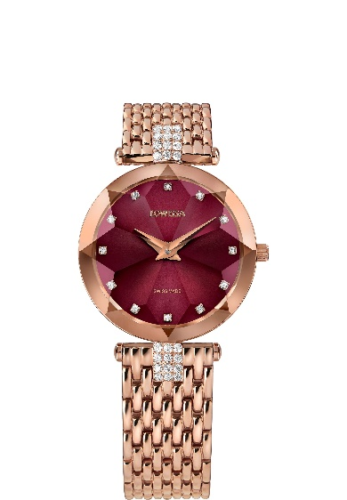

[Facet Strass Swiss Ladies WATCH J5.714.M](https://www.jowissa.com/products/facet-strass-swiss-ladies-watch-j5-714-m)

€269.90

|  |  |
| --- | --- |
| WATCH CASE | Stainless Steel Case with Pavé Set Rhinestones |
| CASE DIAMETER | 29.5 mm |
| CASE HEIGHT | 9 mm |
| WATER RESISTANCE | 5 ATM (shower-proof) |
| ADJUSTMENT RANGE | Wrist circumference of 120-205 mm |
| GENDER | Female |
| SWISS MADE | Hand-assembled in Switzerland |
| COLOR | Rose / Mother-of-Pearl |
| REFERENCE | J5.635.M |

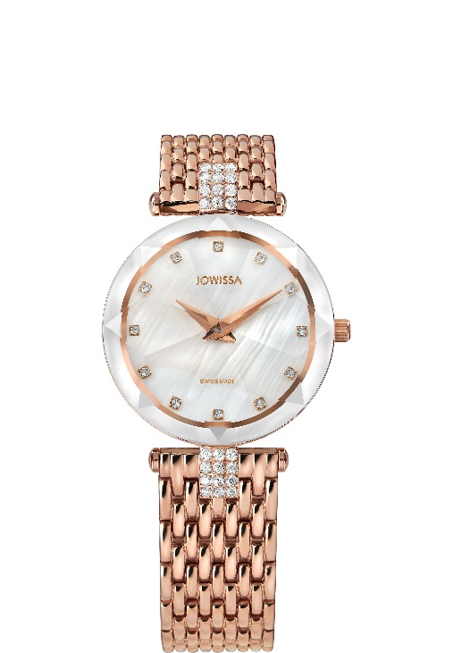

[Facet Strass Swiss Ladies WATCH J5.635.M](https://www.jowissa.com/products/facet-strass-rose-mother-of-pearl-mesh-j5-635-m)

€269.90

Aura Male

|  |  |
| --- | --- |
| WATCH CASE | Stainless steel |
| CASE DIAMETER | 40 mm |
| CASE HEIGHT | 8 mm |
| WATER RESISTANCE | 5 ATM (shower-proof) |
| ADJUSTMENT RANGE | Wrist circumference of 185-225 mm |
| GENDER | Male |
| SWISS MADE | Hand-assembled in Switzerland |
| COLOR | Gold / Brown |
| REFERENCE | J4.274.L |

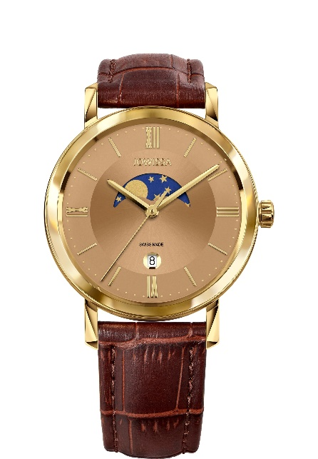

[Magno Swiss Men's WATCH J4.274.L](https://www.jowissa.com/products/magno-swiss-mens-watch-j4-274-l)

€269.90

|  |  |
| --- | --- |
| WATCH CASE | Stainless steel |
| CASE DIAMETER | 40 mm |
| CASE HEIGHT | 8 mm |
| WATER RESISTANCE | 5 ATM (shower-proof) |
| ADJUSTMENT RANGE | Wrist circumference of 185-225 mm |
| GENDER | Male |
| SWISS MADE | Hand-assembled in Switzerland |
| COLOR | Steel / Black |
| REFERENCE | J4.276.L |

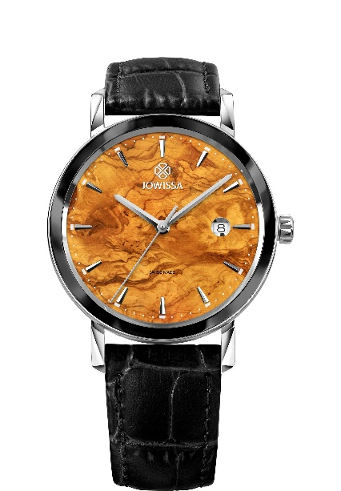

[Magno Swiss Men's WATCH J4.276.L](https://www.jowissa.com/products/magno-swiss-mens-watch-j4-276-l)

€269.90

|  |  |
| --- | --- |
| WATCH CASE | Stainless steel |
| CASE DIAMETER | 42 mm |
| CASE HEIGHT | 11 mm |
| WATER RESISTANCE | 5 ATM (shower-proof) |
| ADJUSTMENT RANGE | Wrist circumference of 160-225 mm |
| GENDER | Male |
| SWISS MADE | Hand-assembled in Switzerland |
| COLOR | Rose / Black |
| REFERENCE | J7.021.L |

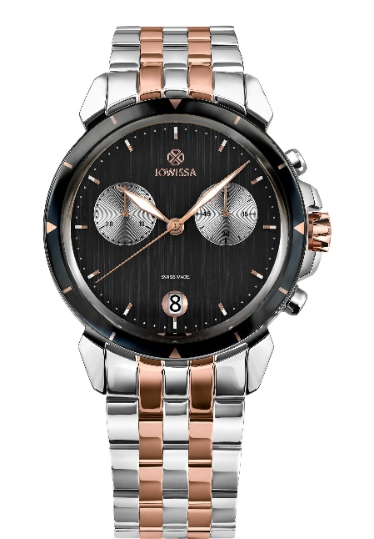

[LeWy 6 Swiss Men's WATCH J7.021.L](https://www.jowissa.com/products/lewy-6-swiss-mens-watch-j7-021-l)

[€ 379,90](https://www.jowissa.com/products/lewy-6-swiss-mens-watch-j7-021-l)

|  |  |
| --- | --- |
| WATCH CASE | Stainless steel |
| CASE DIAMETER | 42 mm |
| CASE HEIGHT | 11 mm |
| WATER RESISTANCE | 5 ATM (shower-proof) |
| ADJUSTMENT RANGE | Wrist circumference of 170-225 mm |
| GENDER | Male |
| SWISS MADE | Hand-assembled in Switzerland |
| COLOR | Steel / Black / Red |
| REFERENCE | J7.135.L |

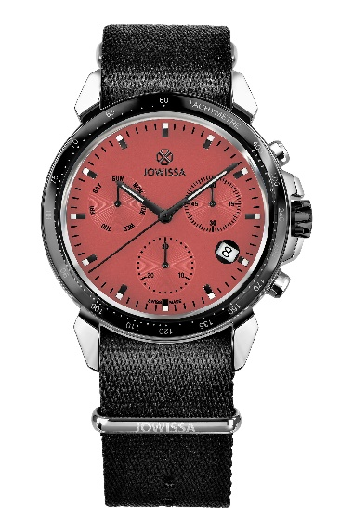

[LeWy 9 Swiss Men's WATCH J7.135.L](https://www.jowissa.com/products/lewy-9-swiss-mens-watch-j7-135-l)

[€ 339,90](https://www.jowissa.com/products/lewy-9-swiss-mens-watch-j7-135-l)